HANDSMEN THREADS

Salesforce Project
Documentation
  - Custom Objects, Automation, Security and Test Evidence
A project report for the HandsMen Threads fashion retail CRM built on Salesforce. It describes the data model and controls visible in the supplied Setup screenshots, and records the intended behavior of the named automation and communications components.
Submitted by
ARAVINDHAN S (24CSR024)
CSE

Document | Details
Project | HandsMen Threads Salesforce CRM
Platform | Salesforce Developer Edition
Prepared | 10 October 2026
Evidence set | 40 Salesforce Setup screenshots dated 7–10 October 2026

Purpose
Provide a reviewable record of the project configuration, connect the visible Salesforce setup to the business requirements, and identify the runtime checks needed before relying on automation in day-to-day operations.

Executive Summary
HandsMen Threads uses Salesforce to organize customer, product, order, inventory and marketing campaign records. The screenshots confirm the HandsMen Threads Lightning app with five deployed custom objects and their tabs, fields and relationships, an inventory stock-status formula field, three active validation rules that were tested with invalid entries, two active flows with debug runs, Scheduled Jobs entries, two classic email templates and three email alerts, a custom profile named Platform 1, the Sales1 role in the KEC SOLUTION role hierarchy, and sample records for all five objects.
The configuration gives the project a clear data foundation, and the evidence includes sample records, rejected invalid entries for all three validation rules, and flow debug runs. Scheduled job history, email delivery receipts, and user-based access tests remain separate from this Setup evidence.

User Story
HandsMen Threads is a fashion organization that needs a central CRM for customer relationships and the operational records behind product sales. Sales staff need to manage customers and orders; inventory staff need to maintain stock visibility; and marketing staff need campaign and loyalty information to support relevant customer communication.
- As a sales representative, I want customer and order records linked so that purchases can be followed up reliably.
- As an inventory manager, I want product stock and warehouse information in Salesforce so that shortages can be found before fulfillment is affected.
- As a marketing user, I want campaign and customer information together so that outreach can be planned and targeted.
- As an administrator, I want field validation and access controls so that the records remain usable and are exposed to the right users.

Project Objectives
Objective | Project contribution
Centralize records | Maintain customer, product, order, inventory and campaign data in Salesforce custom objects.
Protect data quality | Use active validation rules for order amount, inventory quantity and customer email input.
Surface operational signals | Use the Stock Alert Flow and Stock Status field to support low-stock action.
Support retention | Use the Loyalty Status Update Flow and Loyalty Program Email for customer loyalty communication.
Control access | Use Salesforce profiles and roles to manage permissions and record visibility.

Document Map
The report follows the project sequence from overview and requirements through data design, configuration evidence, automation, access, testing, milestones and future enhancements.

1 Project Overview and Requirements

1.1 Project Overview
The HandsMen Threads Salesforce CRM is a custom-object solution for managing the core records involved in men's fashion retail. The custom schema connects customer and order records, product and inventory records, and customer-related marketing campaigns. Salesforce validation rules enforce basic input controls, while Flow Builder is intended to support inventory alerts and loyalty status updates.

1.2 Ideation
The project brings customer-facing information and retail operations into one Salesforce workspace. A shared record model can reduce duplicate entry, make related information easier to review, and create a place for automated alerts and customer communications. Inventory is represented separately from the product catalogue so stock quantity and warehouse location can be maintained as operational data.

1.3 Functional Requirements
ID | Requirement | Salesforce area
FR-01 | Create and maintain customer records with a validated email address. | HandsMen Customer; validation rule Email
FR-02 | Maintain products with SKU, price and stock quantity. | HandsMen Product
FR-03 | Record customer orders with customer, product, quantity, status and total amount. | HandsMen Order
FR-04 | Maintain stock quantities and warehouse details for products. | Inventory; master-detail to HandsMen Product
FR-05 | Record campaign start and end dates and associate campaigns with customers. | Marketing Campaign
FR-06 | Prevent invalid total amounts, negative stock quantities and malformed email values. | Validation Rules
FR-07 | Notify the responsible team when stock is low. | Stock Alert Flow; Low Stock Alert email
FR-08 | Update loyalty status and communicate program changes. | Loyalty Status Update Flow; Loyalty Program Email

1.4 Quality and Access Requirements
- Keep related records connected through lookups and a master-detail relationship.
- Make data entry errors visible with clear validation messages.
- Ensure Flow actions, scheduled processes and email delivery are permissioned and monitored.
- Keep customer contact data accessible only to users who need it for their work.
Requirement boundary
Exact stock thresholds, loyalty tiers, scheduled run times and email wording must match the active org configuration. They are not specified by the visible Setup screenshots and are therefore treated as configuration values to confirm.

2 Salesforce Solution Design

2.1 Data Flow
The project can be understood as four connected stages: users enter records in Lightning, Salesforce stores them in custom objects, validation and automation evaluate the records, and users receive operational outputs such as alerts and customer messages.
1 Record entry | 2 Salesforce data | 3 Controls and automation | 4 Business output
Sales and operations users create or update records. | HandsMen Customer, HandsMen Product, HandsMen Order, Inventory and Marketing Campaign. | Validation Rules; Stock Alert Flow; Loyalty Status Update Flow; scheduled processing. | Accurate records, low-stock notifications, loyalty updates and campaign follow-up.

2.2 Relationship Map
Related object | Relationship field | Type shown in Setup | Interpretation
HandsMen Customer to HandsMen Order | HandsMen Order.HandsMen_Customer__c | Lookup(HandsMen Customer) | Each order can reference a customer.
HandsMen Product to HandsMen Order | HandsMen Order.HandsMen_Product__c | Lookup(HandsMen Product) | Each order references a product.
HandsMen Product to Inventory | Inventory.HandsMen_Product__c | Master-Detail(HandsMen Product) | Inventory is a detail record under a product.
HandsMen Customer to Marketing Campaign | Marketing Campaign.HandsMen_Customer__c | Lookup(HandsMen Customer) | A campaign record can reference a customer.

Data model observation
Each HandsMen Order holds one HandsMen Product lookup, so an order can reference a single product. If an order must contain multiple products, an Order Item junction object is a useful enhancement so each order line can hold its own product, quantity and price.

2.3 Salesforce Components
Layer | Project components
User interface | Salesforce Lightning record pages and object tabs
Data | Five deployed custom objects and their configured fields and relationships
Data quality | Active Total_Amount, Stock_Quantity and Email validation rules
Automation | low stock alert - V1 (record-triggered), loyality program - V1 (scheduled) and Scheduled Apex jobs
Communication | Loyalty Program e and Low Stock Alert templates; Low Stock alert, Loyalty program email and Order Confirmation Email Alert email alerts
Access | Profiles and role hierarchy

3 Custom Objects and Field Configuration

3.1 HandsMen Product
HandsMen Product holds catalogue information. The visible fields are a product name, SKU, price and stock quantity. The object’s Name field is configured as the HandsMen Product Name text field.
Field label | API name | Data type shown
HandsMen Product Name | Name | Text(80)
Price | Price__c | Currency(18, 0)
SKU | SKU__c | Text(60)
Stock Quantity | Stock_Quantity__c | Number(18, 0)

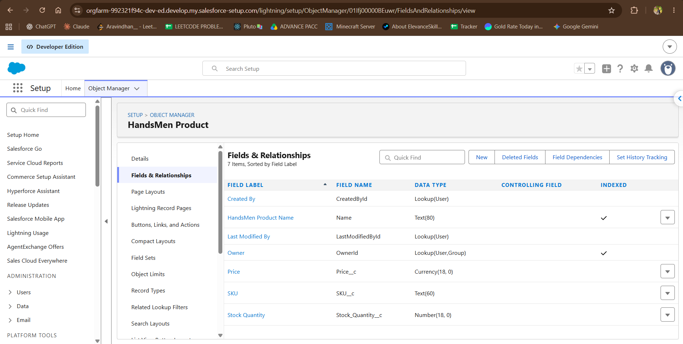
Figure 1. HandsMen Product fields and relationships in Salesforce Setup (7 fields listed, including SKU, Price and Stock Quantity).

3.2 HandsMen Order
HandsMen Order represents a customer purchase. Salesforce assigns the order number through an auto-number Name field. The configured fields also capture the customer and customer email, the ordered product, quantity, order status and total amount.
Field label | API name | Data type shown
HandsMen OrderNumber | Name | Auto Number
HandsMen Customer | HandsMen_Customer__c | Lookup(HandsMen Customer)
HandsMen Product | HandsMen_Product__c | Lookup(HandsMen Product)
Customer Email | Customer_Email__c | Email
Quantity | Quantity__c | Number(18, 0)
Status | Status__c | Picklist
Total Amount | Total_Amount__c | Number(18, 0)

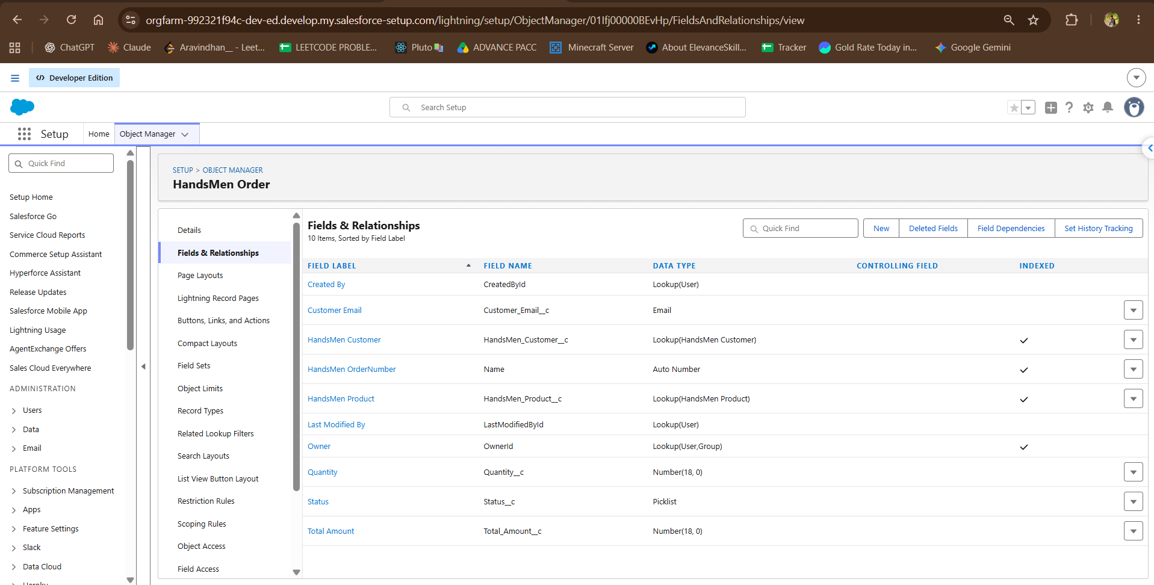
Figure 2. HandsMen Order fields in Salesforce Setup, including the HandsMen Customer and HandsMen Product lookups (10 fields listed).

3.3 Inventory
Inventory stores stock quantity and warehouse information under a HandsMen Product record. Its Name field uses an auto-number. The Product field is a master-detail relationship, so the inventory record is dependent on the selected product.
Field label | API name | Data type shown
Inventory Number | Name | Auto Number
HandsMen Product | HandsMen_Product__c | Master-Detail(HandsMen Product)
Stock Quantity | Stock_Quantity__c | Number(18, 0)
Warehouse | Warehouse__c | Text(60)

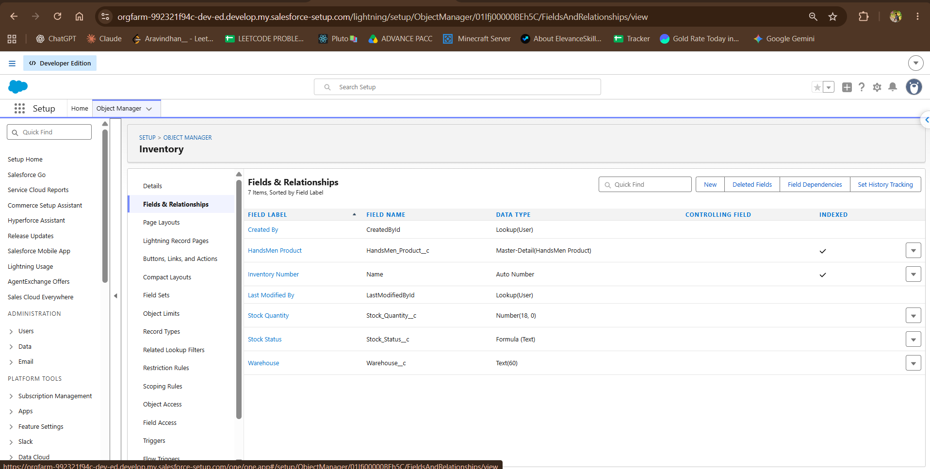
Figure 3. Inventory fields, including the master-detail relationship to HandsMen Product.

3.4 Inventory Stock Status
A later Inventory fields screenshot shows Stock Status as a formula field with Text output. This provides a readable status derived from inventory data and can support the Stock Alert Flow. The formula expression and threshold are not visible in the screenshot.
Field label | API name | Data type shown | Use
Stock Status | Stock_Status__c | Formula (Text) | Display a status derived from inventory values; confirm the formula and its threshold in Setup.

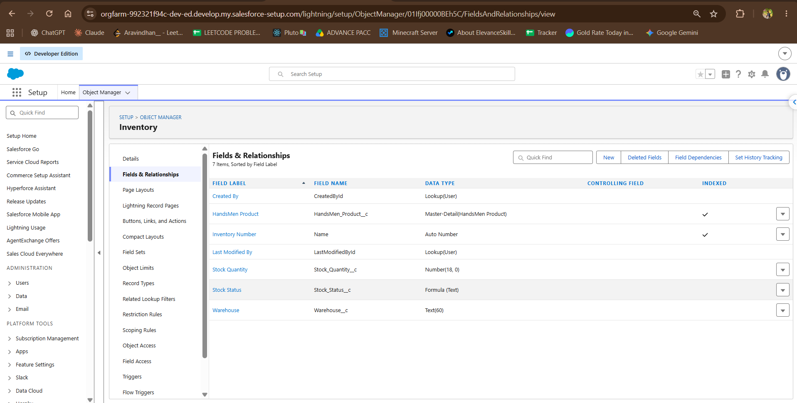
Figure 4. Inventory fields with the Stock Status formula field highlighted.

3.5 Marketing Campaign
Marketing Campaign records a campaign date range and associates a campaign with a HandsMen Customer record. The object uses an auto-number for its Name field.
Field label | API name | Data type shown
Marketing Campaign Number | Name | Auto Number
Start Date | Start_Date__c | Date
End Date | End_Date__c | Date
HandsMen Customer | HandsMen_Customer__c | Lookup(HandsMen Customer)

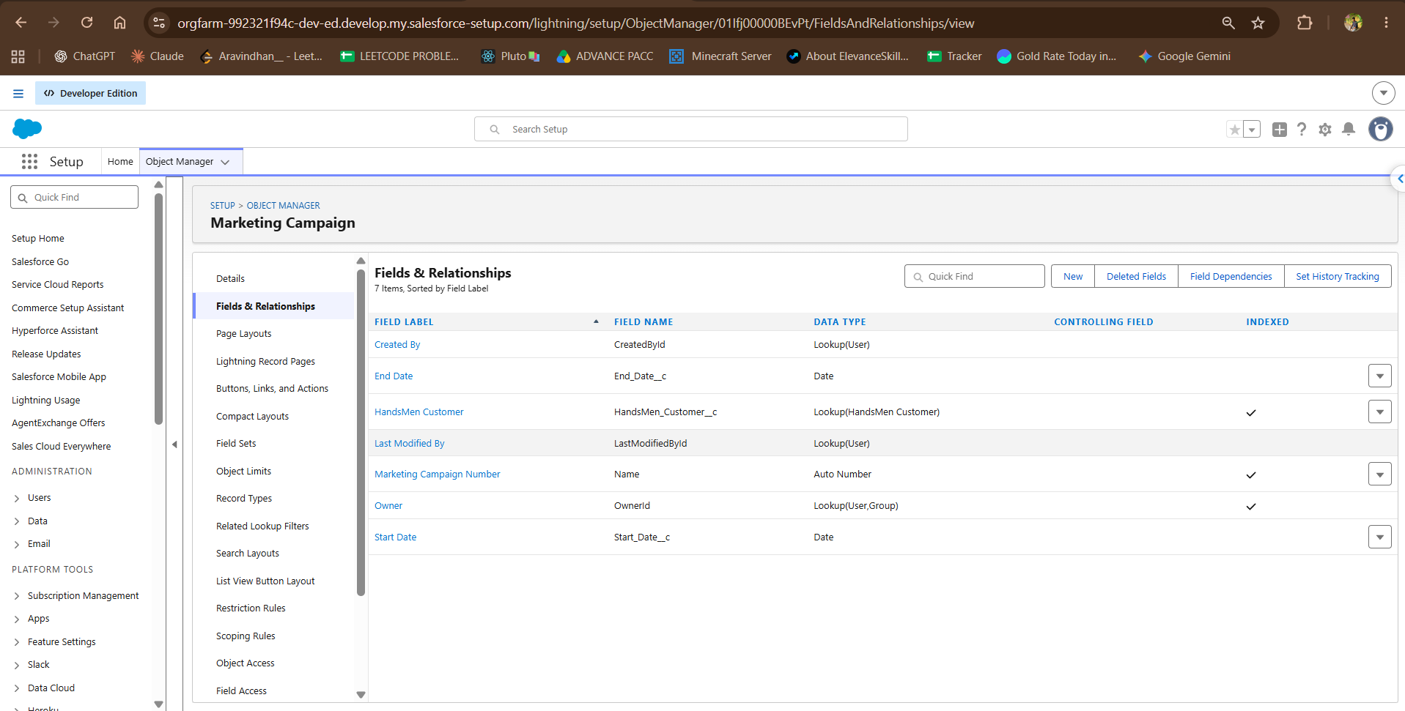
Figure 5. Marketing Campaign date fields and customer lookup in Salesforce Setup.

3.6 HandsMen Customer
HandsMen Customer is referenced by both HandsMen Order and Marketing Campaign through lookup fields. The Email validation rule is active on this object. Setup lists 11 fields on the object, including contact details, name fields, a FullName formula, a Loyalty Status picklist and Total Purchases (Figure 17).
Field label | API name | Data type shown
Email | Email__c | Email
FirstName | FirstName__c | Text(60)
FullName | FullName__c | Formula (Text)
HandsMen Customer Name | Name | Text(80)
LastName | LastName__c | Text(60)
Loyalty Status | Loyalty_Status__c | Picklist
Phone | Phone__c | Phone
Total Purchases | Total_Purchases__c | Number(18, 0)

4 Validation Rules
Three active validation rules are visible in the Salesforce Setup screenshots. Their names, error locations and messages are captured below. The screenshots show rule activation but not the formula expressions; confirm those expressions in Setup when reviewing the exact acceptance conditions.
Object | Rule | Error location | Error message | Status
HandsMen Order | Total_Amount | Total Amount | Please Enter Correct Amount | Active
Inventory | Stock_Quantity | Top of Page | the inventory count is never less than zero | Active
HandsMen Customer | Email | Top of Page | Please fill Correct Gmail | Active

4.1 Order Amount
The active Total_Amount rule appears on HandsMen Order and displays its error beside the Total Amount field. It is intended to reject an invalid amount. The exact invalid range or formula condition should be read from the rule definition before functional testing.
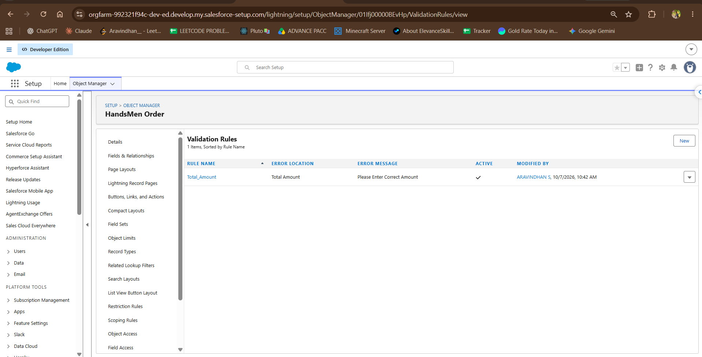
Figure 6. Active Total_Amount validation rule on HandsMen Order, with the message Please Enter Correct Amount. Last modified 7 October 2026.

4.2 Inventory Quantity
The active Stock_Quantity rule is intended to prevent negative inventory counts. Its message is displayed at the top of the page.
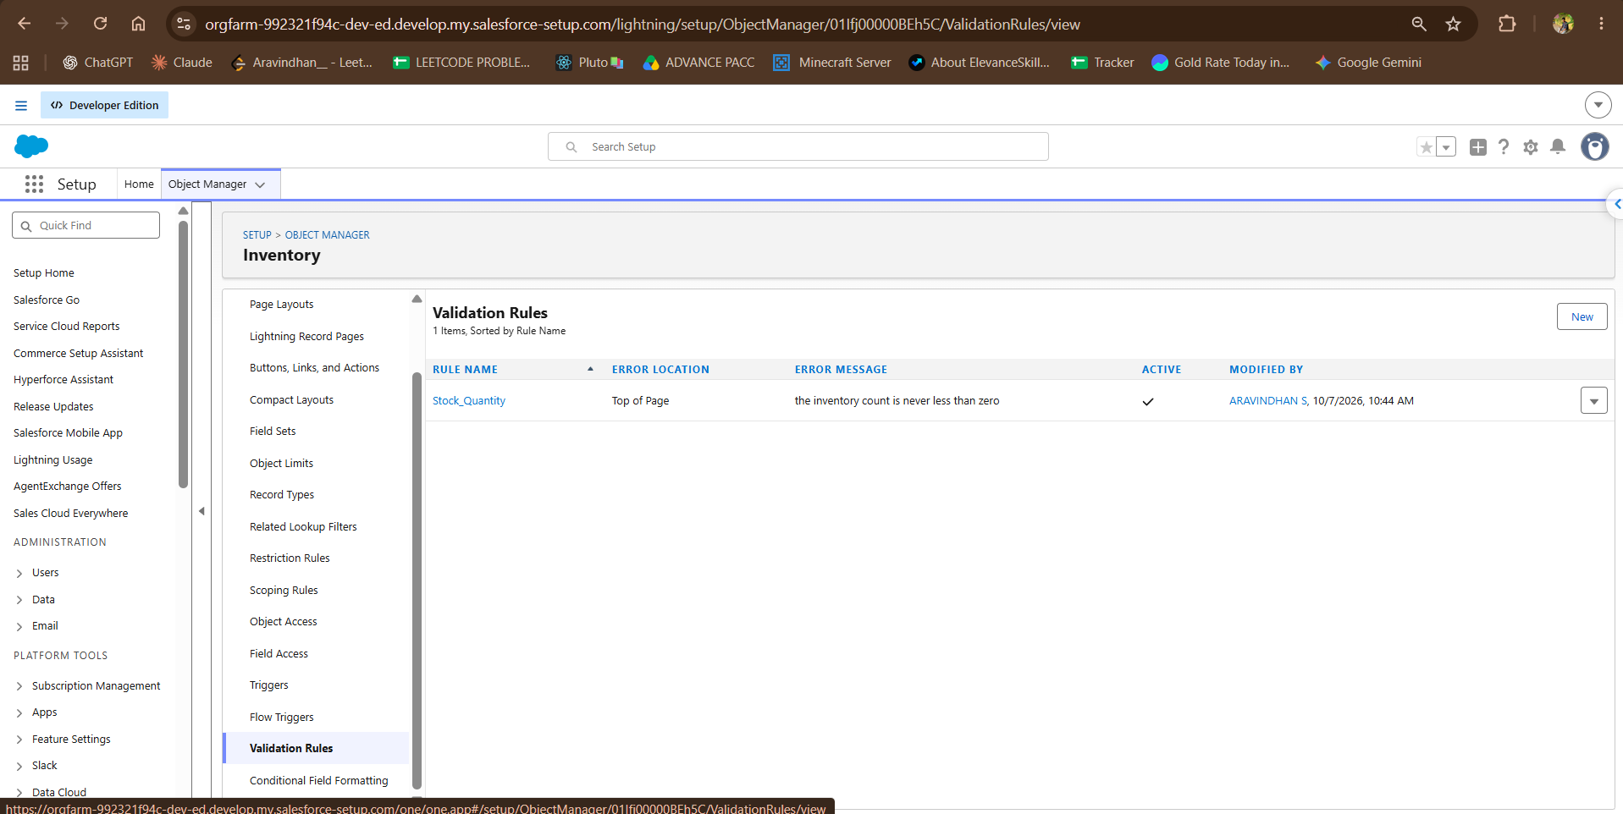
Figure 7. Active Stock_Quantity validation rule on Inventory. Last modified 7 October 2026.

4.3 Customer Email
The active Email rule is associated with HandsMen Customer and displays the message Please fill Correct Gmail. This control supports basic email data quality. Verify the formula against the org’s expected email formats and test both valid and invalid entries.
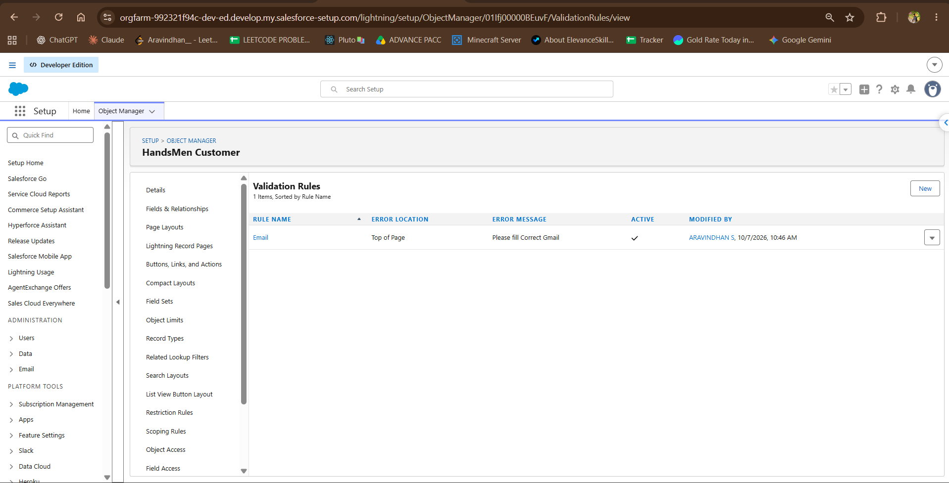
Figure 8. Active Email validation rule on HandsMen Customer. Last modified 7 October 2026.
Validation test evidence
The screenshots verify that these three rules are active in Setup. They do not show records being saved or rejected, so runtime outcomes are listed as pending execution in the test section.

5 Flow Builder Automations
Flow Builder is used to automate stock notifications and customer loyalty updates. Two flows are shown as Active: low stock alert - V1 (last saved 8 October 2026, 11:47 PM) and loyality program - V1 (last saved 8 October 2026, 11:57 PM). The canvases record the entry configuration and main actions (Figures 23 and 24). Debug runs on 10 October 2026 are shown in Figures 39 and 40: the loyalty flow completed and retrieved HandsMen_Customer__c records, while the low stock alert run reported Not Triggered, meaning the debug input did not satisfy the start condition. A record that meets the condition is needed to exercise its email action.

5.1 Stock Alert Flow
Design element | Project behavior
Purpose | low stock alert - V1 is shown active as a record-triggered flow on Inventory. Trigger: a record is created or updated, with one condition; optimized for Actions and Related Records.
Relevant records | Inventory and its related HandsMen Product.
Potential output | The Run Immediately path calls an email action named low stock alert.
Configuration to verify | Confirm the condition and low-stock threshold, recipients, duplicate-alert handling, and fault path. The 19:03 debug run returned Not Triggered (Figure 39); re-run it with a record that meets the start condition.

5.2 Loyalty Status Update Flow
Design element | Project behavior
Purpose | loyality program - V1 is shown active as a schedule-triggered flow that starts on 8 October 2026 at 12:00 AM with frequency Once.
Relevant records | HandsMen Customer records retrieved by the Get customers element and processed one by one in a loop.
Potential output | A loyalty status check routes each customer to the gold, Bronze or Silver update element, then the loyality program email action runs. The decision conditions are not visible.
Configuration to verify | Confirm decision conditions, status values, recurrence (the canvas shows Once), repeat-processing behavior, and fault path. The 19:05 debug run completed (Figure 40).

Flow Builder review
Use Flow Builder debug details and a representative record to confirm each decision outcome. Record the active flow version, triggering event, conditions and email action after verifying them in the org.

5.3 Scheduled Processing
The Scheduled Jobs page lists two user-submitted Scheduled Apex jobs, both submitted by S. ARAVINDHAN: Daily Inventory Sync (next run 11 October 2026, 12:00 AM) and schedule customer status to be updated (next run 10 October 2026, 10:00 AM). The page reports 2 of 100 scheduled Apex jobs used (2%); the other entries are system jobs (Figure 25). Confirm the final recurrence, time zone and run history before operational reliance.
Job detail | Value to record
Job or flow name | Daily Inventory Sync; schedule customer status to be updated
Execution mechanism | Scheduled Apex (both entries). The loyalty flow is a separate schedule-triggered flow.
Schedule | Daily Inventory Sync next run 11 October 2026, 12:00 AM; schedule customer status to be updated next run 10 October 2026, 10:00 AM.
Processing scope | Records selected and batch-safe behavior
Monitoring | Owner, last/next run, failure handling and retry approach

6 Email Templates
Two classic email templates are shown: Loyalty Program e (HTML, Free Form Letter layout, Handsmen Threads letterhead, subject HI) and Low Stock Alert (text template, subject Low stock Alert Email, addressed to the Inventory Manager with merge fields for the product and current stock quantity). Both are marked Available For Use and use UTF-8 encoding (Figures 26 and 27). Three email alerts are also configured (Figures 28–30): Low Stock alert on Inventory, Loyalty program email on HandsMen Customer (recipient: the customer Email field), and Order Confirmation Email Alert on HandsMen Order (recipient: the Customer Email field). Each uses the current user’s email address as the From address, and Setup reports that none is used by classic workflow rules, approval processes or entitlement processes; the flow canvases show email actions with matching names. No automation that uses the Order Confirmation Email Alert is visible, and email delivery results are not captured.
Template name | Intended use | Configuration to verify
Low Stock Alert | Notify the inventory manager when a product requires replenishment. Used by the Low Stock alert email alert on Inventory (Figures 27 and 28). | Subject and body, inventory/product merge fields, recipient source, sender, active Flow action and delivery test.
Loyalty Program e | Inform a customer about a loyalty status update or program communication. Displayed subject: HI. | Subject and body, customer merge fields, status wording, recipient source, sender, consent rules and delivery test.
Order Confirmation Email | Confirm an order to the customer through the Customer Email field on HandsMen Order. Template content not shown; the email alert is visible (Figure 30). | Subject and body, order merge fields, recipient source, sender, triggering automation and delivery test.

Email verification checklist
- Preview every template with a record that contains realistic customer and product values.
- Confirm the Flow passes the intended recipient and the required merge-field record context.
- Check sender identity, org-wide email permissions and deliverability settings.
- Send a test message to an approved test mailbox and record the result before production use.
Customer communication
Keep email content aligned with the customer’s relationship to HandsMen Threads and the purpose of the message. Confirm consent and the organization’s communication preferences before campaign or loyalty outreach.

7 Roles and Profiles
Salesforce profiles define baseline permissions such as object access and flow or Apex access. Roles primarily shape record visibility through the role hierarchy and sharing model. Both layers should be reviewed together for each project user group.

7.1 Profile Evidence
The screenshot shows a custom profile named Platform 1 with the Salesforce user license, created by ARAVINDHAN S on 7 October 2026. In the visible profile summary, Enabled Apex Class Access and Enabled Flow Access each show zero entries. This is a point-in-time Setup view; confirm the final user profiles and their object, field, Apex and Flow permissions against the intended tasks.
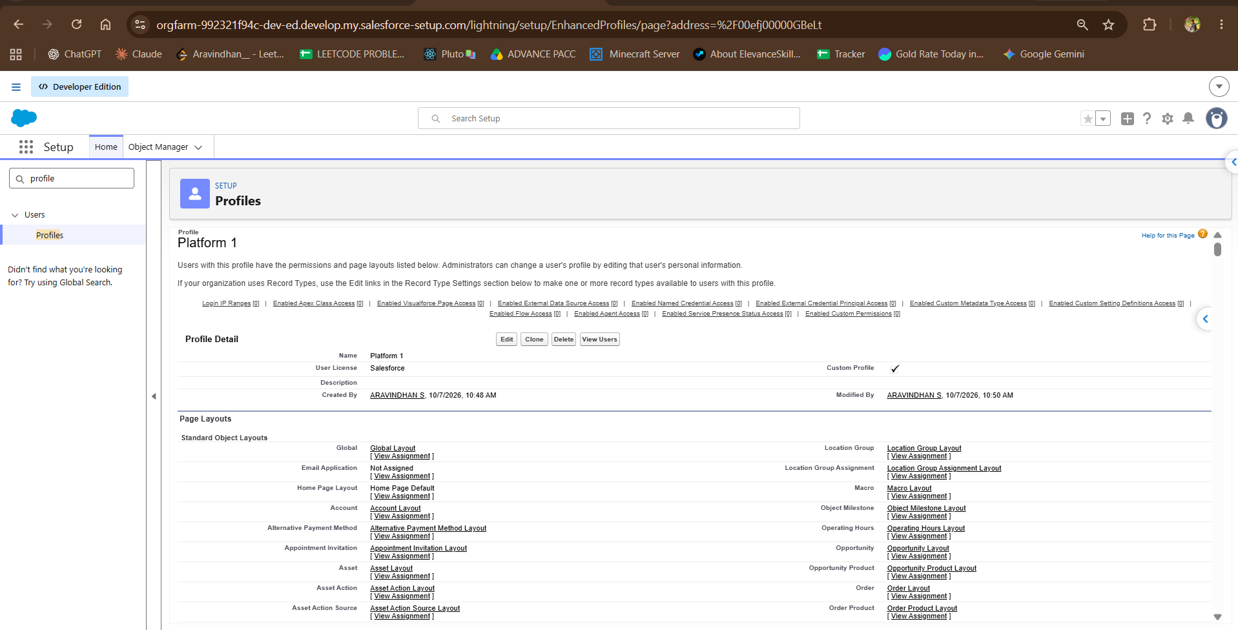
Figure 9. Platform 1 profile detail, marked as a custom profile, with the visible Apex Class Access and Flow Access counts. Created and modified 7 October 2026.

7.2 Role Responsibilities
Business function | Access responsibility | Evidence status
Sales | Manage customer and order records needed to support sales work. | Sales1 role is visible under KEC SOLUTION > CEO > Sales1. The screenshot shows no users assigned to this role.
Inventory | Maintain inventory quantity, warehouse information and replenishment follow-up. | Inventory role appears as a sibling role under CEO in the Sales1 hierarchy view. User assignment not captured.
Marketing | Manage campaign records and approved customer loyalty communications. | Marketing role appears as a sibling role under CEO in the Sales1 hierarchy view. User assignment not captured.

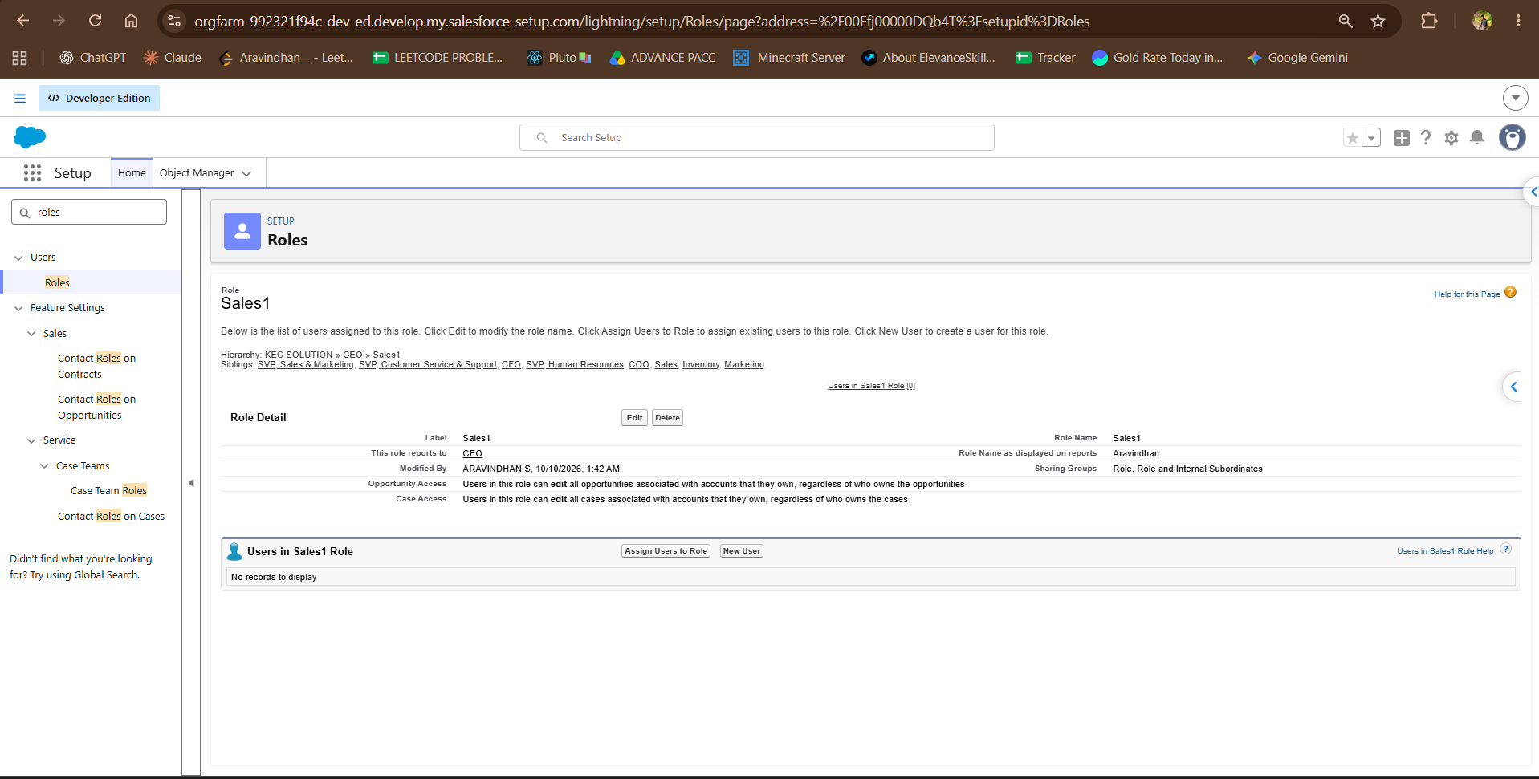
Figure 10. Sales1 role detail in the KEC SOLUTION role hierarchy. The view shows no users assigned to this role. Last modified 10 October 2026.

Access checks before user assignment
- Assign users to the correct role and an approved profile; do not rely on role names to grant object permissions.
- Confirm HandsMen Customer, HandsMen Product, HandsMen Order, Inventory and Marketing Campaign permissions by task.
- Review field-level access for customer contact details, pricing and loyalty status.
- Confirm Flow and Apex access for automation owners and users who invoke those processes.

8 Testing and Results
The supplied evidence establishes which metadata items are present and active in Setup, including custom object fields, validation rules, Flow Builder canvases, Scheduled Jobs entries, an email template, the Platform 1 profile and the Sales1 role. It does not include execution logs, saved test records, Flow debug output, scheduled job history, or email delivery receipts. The matrix below distinguishes configuration evidence from runtime results.

8.1 Evidence-Based Results
Area | Observed result | Runtime test status
Custom object schema | Fields and relationship types are visible for all five custom objects (Figures 1–5 and 12–17). | Configuration reviewed; sample records are listed in Figures 31–35.
Inventory status | Stock Status formula field is listed as Formula (Text). | Formula output not captured.
Validation rules | Total_Amount, Stock_Quantity and Email are marked active. | Save/reject behavior captured for all three rules (Figures 36–38).
Platform 1 profile | Profile is marked custom; visible Apex and Flow access counts are zero. | User permission test not captured.
Sales1 role | Role appears in hierarchy with no users assigned in the screenshot. | Record visibility test not captured.
Flows, jobs and email | Active Flow canvases, Scheduled Jobs entries, two Available For Use email templates, three email alerts, and two flow debug runs are visible. | Loyalty flow debug completed; low stock debug returned Not Triggered; email delivery and scheduled job history not captured.

8.2 Functional Test Plan
Test | Input or action | Expected outcome | Result
T-01 | Save an Inventory record with a negative Stock Quantity. | Stock_Quantity blocks the save and shows its message. | Passed: Stock Quantity -11 was rejected (Figure 36).
T-02 | Save a HandsMen Customer with a malformed email value. | Email rule blocks the save and shows its message. | Passed: invalid email was rejected (Figure 38).
T-03 | Save a HandsMen Order with an amount that violates the configured rule. | Total_Amount blocks the save and shows its message. | Passed: Total Amount -50 was rejected (Figure 37).
T-04 | Move inventory through the configured low-stock condition. | Stock Alert Flow performs the configured notification once per intended event. | Partly captured: debug run returned Not Triggered (Figure 39); re-run with a qualifying record.
T-05 | Update a customer so that the configured loyalty criteria are met. | Loyalty Status Update Flow sets the expected status and sends the intended message. | Partly captured: debug run completed (Figure 40); resulting status not captured.
T-06 | Wait for or manually validate the scheduled processing window. | The job completes for the intended records and appears in run history. | Job entries visible (Figure 25); run history not captured.

Test completion record
After executing the matrix, record the test user, test data, date, actual result, screenshots or logs, and any defect. Use positive and negative cases for each rule and include bulk records for scheduled or record-triggered automation.

9 Planning and Development Milestones
Milestone | Work items | Completion evidence
1 Data model | Create five custom objects, fields and relationships. | Object Manager field lists and relationship review.
2 Data quality | Activate order amount, inventory quantity and email validation rules. | Active rule screenshots plus positive/negative save tests.
3 Automation | Build and activate Stock Alert Flow and Loyalty Status Update Flow. | Flow version, debug evidence and record-based tests.
4 Communication | Create Low Stock Alert and Loyalty Program Email templates. | Rendered previews, merge-field checks and delivery test.
5 Security | Configure profiles and role assignments for Sales, Inventory and Marketing work. | Permission review and user-based visibility test.
6 Verification | Run functional, bulk and failure-path tests; review scheduled jobs. | Completed test matrix, job history and issue log.

10 Conclusion
HandsMen Threads has a Salesforce data foundation for customer, product, order, inventory and campaign records. The screenshots demonstrate deployed objects and tabs, key relationships, sample records, three validation rules tested with invalid entries, two active flows with debug runs, Scheduled Jobs, email templates and alerts, and role configuration. The next verification step is to run qualifying records through the low stock flow and the scheduled processing, confirm email delivery, and confirm that user access matches the Sales, Inventory, and Marketing responsibilities.

Future Enhancements
- Add an Order Item junction object to support multiple products per order with line-level quantity, unit price and totals.
- Define a single configurable low-stock threshold and automate stock reduction and replenishment tracking as order status changes.
- Formalize loyalty tiers, point calculation, status transitions and a history of status changes.
- Extend campaign tracking with campaign type, response, conversion and revenue attribution fields where needed.
- Create operational reports and dashboards for open orders, stock by warehouse, low-stock items, customer loyalty and campaign outcomes.
- Add Apex or Flow test coverage, bulk-data tests, failure monitoring and a repeatable deployment checklist as the solution grows.
Project conclusion
The project is ready for a focused verification pass: validate the visible rules with record saves, inspect the named automation in Flow Builder, confirm scheduled-job configuration, and test email delivery and role-based access with representative users.

Appendix A Supplemental Salesforce Evidence
This appendix records the application navigation, deployed custom object details, customer fields, custom tabs, flows, scheduled jobs, email templates and alerts, sample records, validation tests and flow debug runs from the project org.

A.1 Application Navigation and Object Details
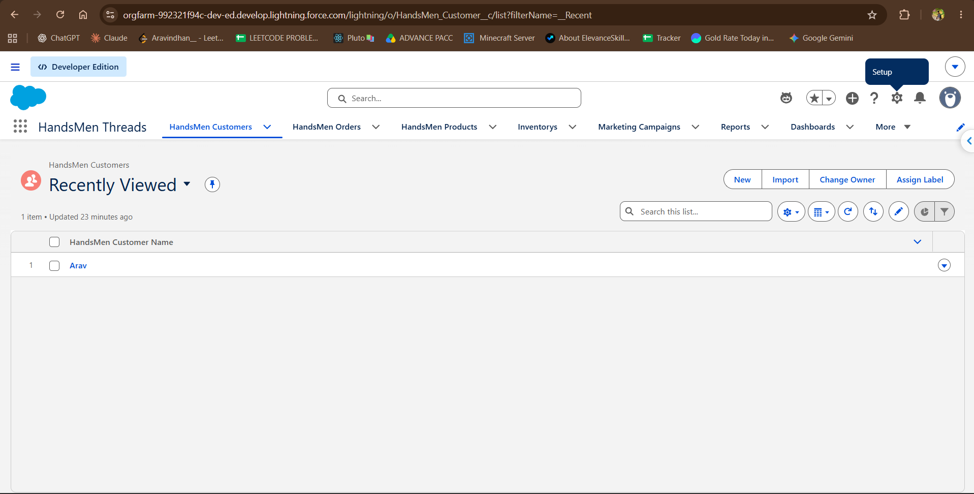
Figure 11. HandsMen Threads Lightning app navigation and HandsMen Customers list view.
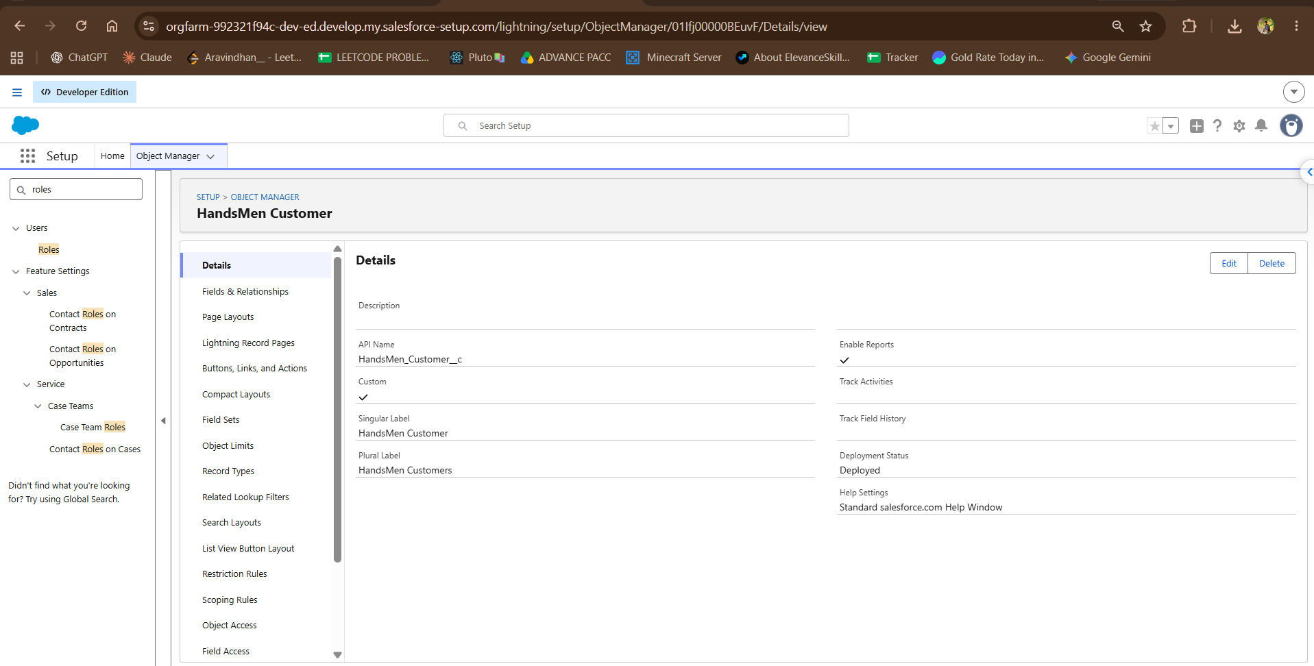
Figure 12. HandsMen Customer custom object details (API name HandsMen_Customer__c, Deployed).
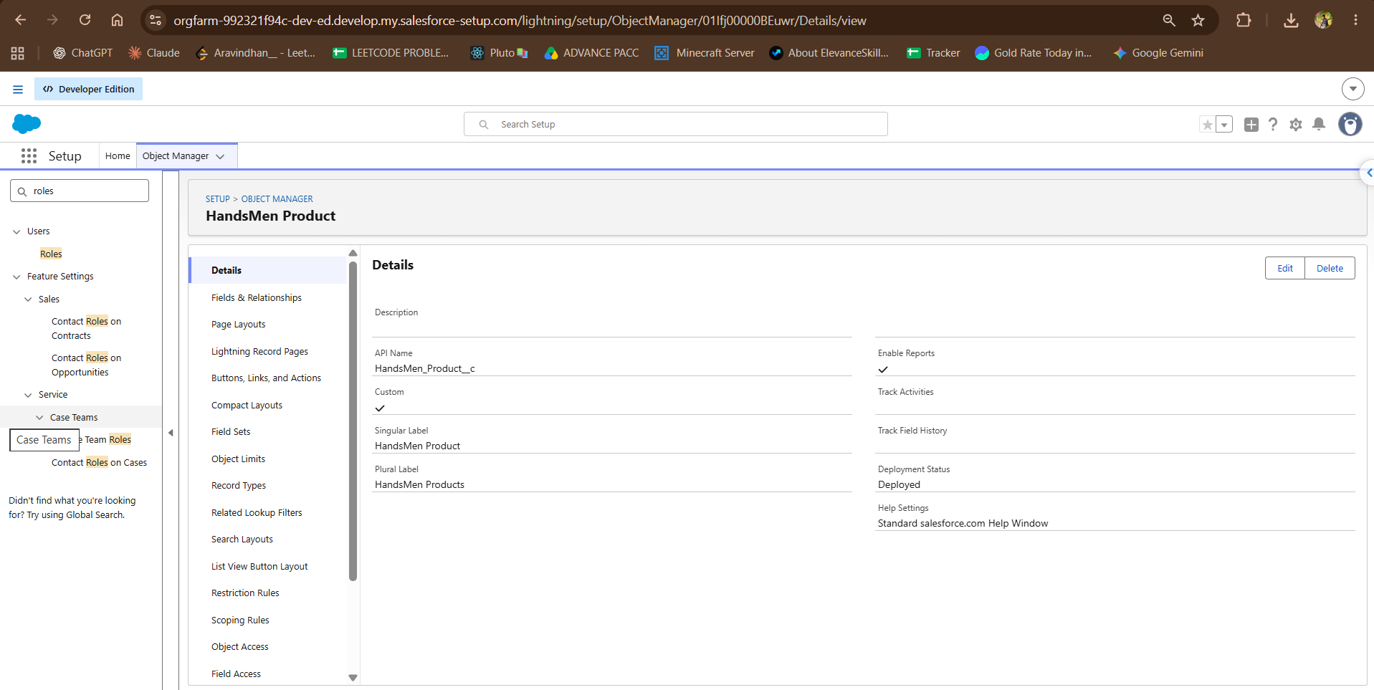
Figure 13. HandsMen Product custom object details (API name HandsMen_Product__c, Deployed).
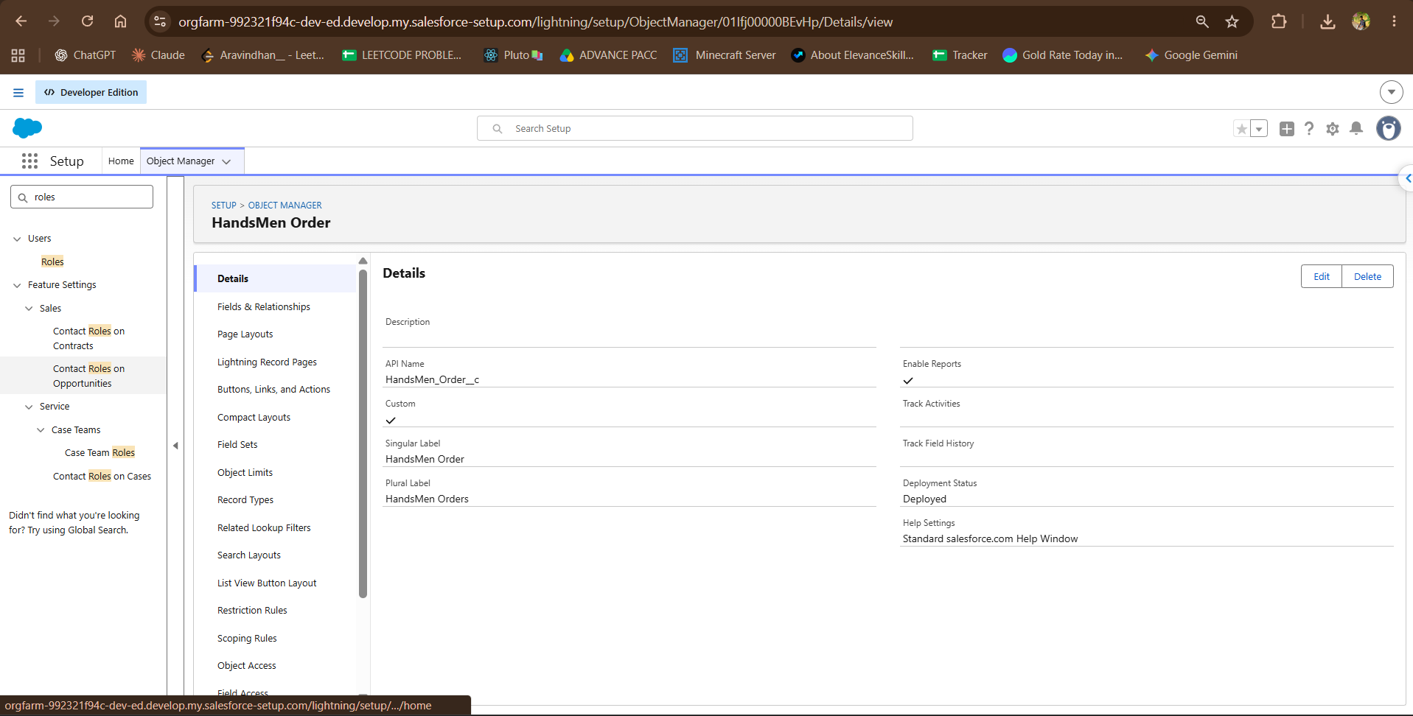
Figure 14. HandsMen Order custom object details (API name HandsMen_Order__c, Deployed).
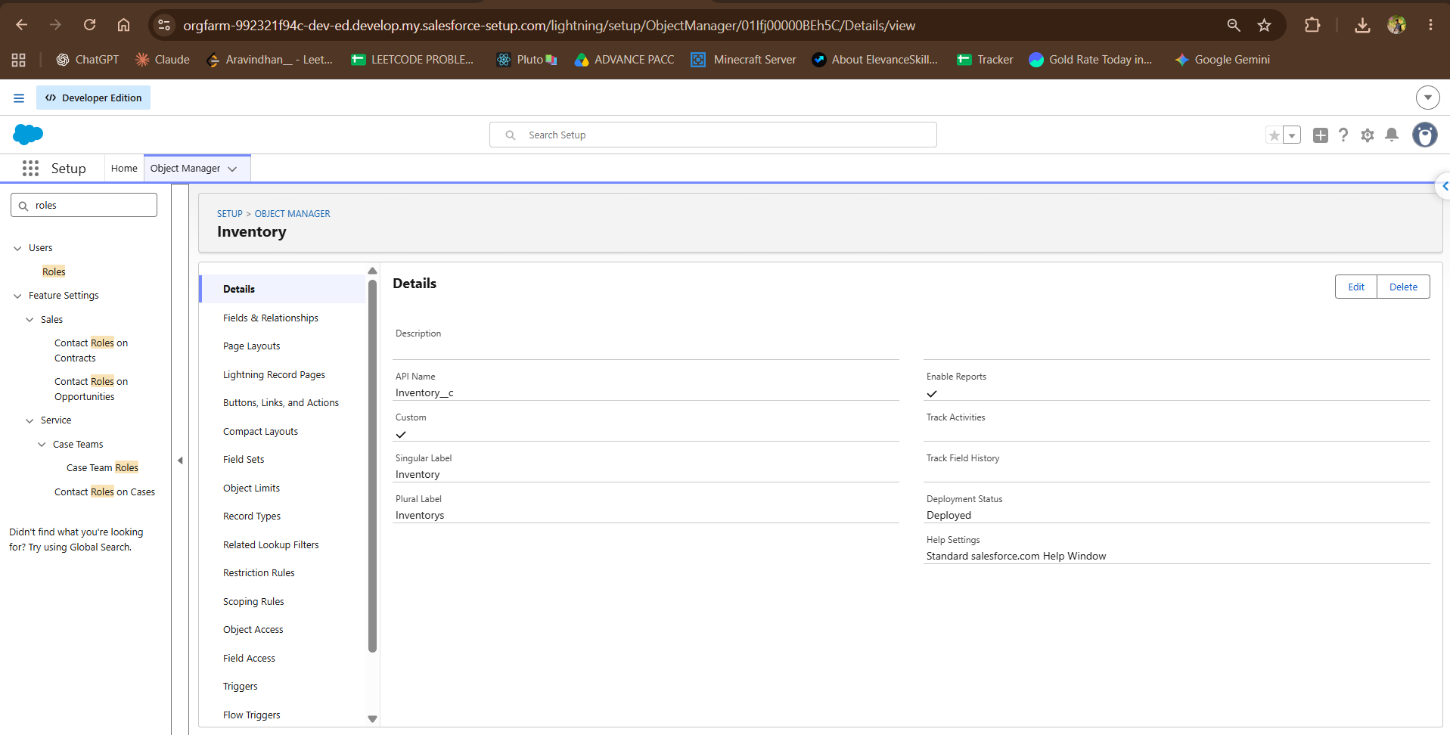
Figure 15. Inventory custom object details (API name Inventory__c, Deployed).
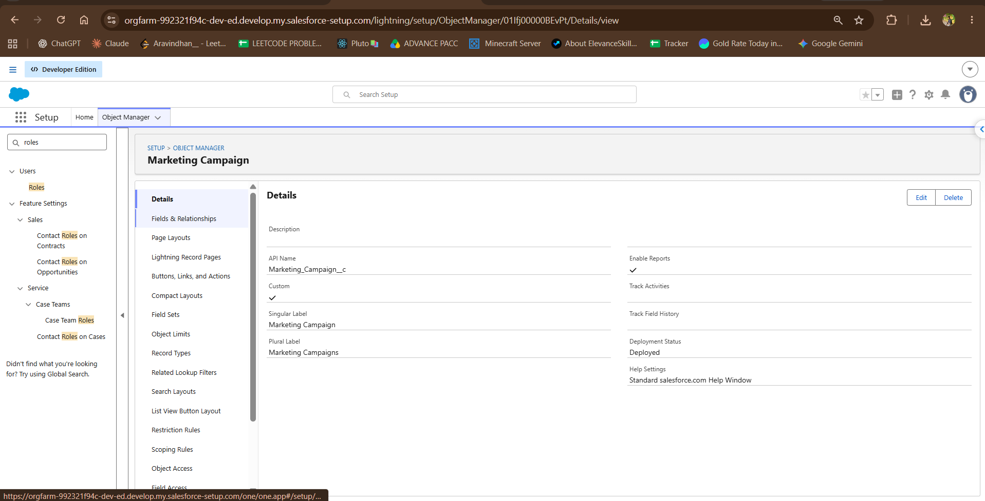
Figure 16. Marketing Campaign custom object details (API name Marketing_Campaign__c, Deployed).

A.2 HandsMen Customer Fields
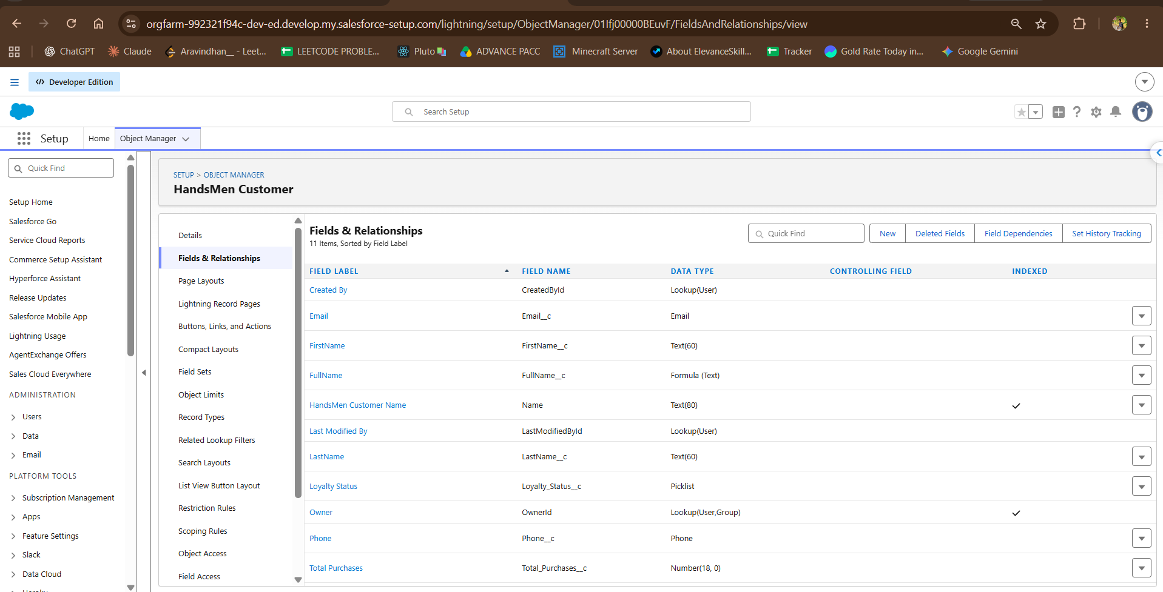
Figure 17. HandsMen Customer fields and relationships (11 items), including Email, FullName formula, Loyalty Status and Total Purchases.

A.3 Custom Object Tabs
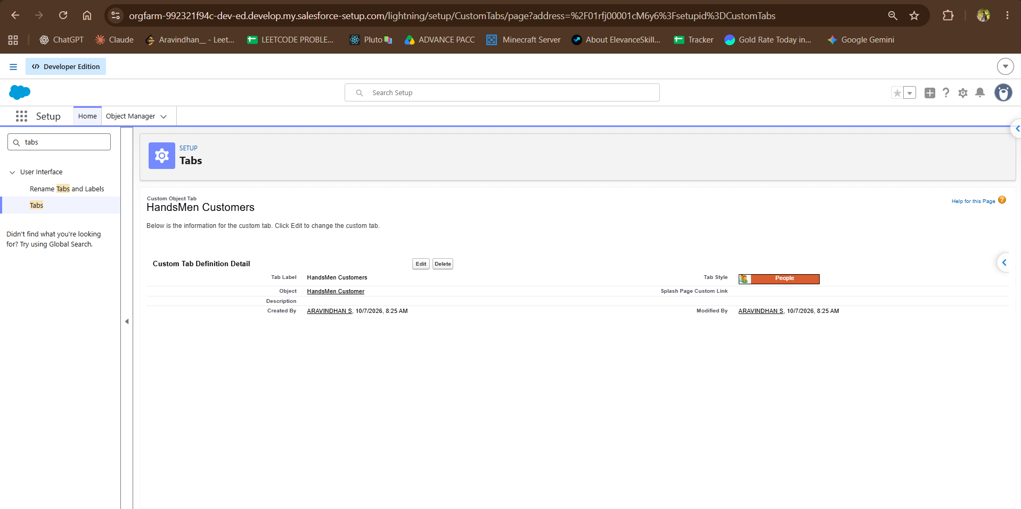
Figure 18. HandsMen Customers custom tab definition (People style, created 7 October 2026).
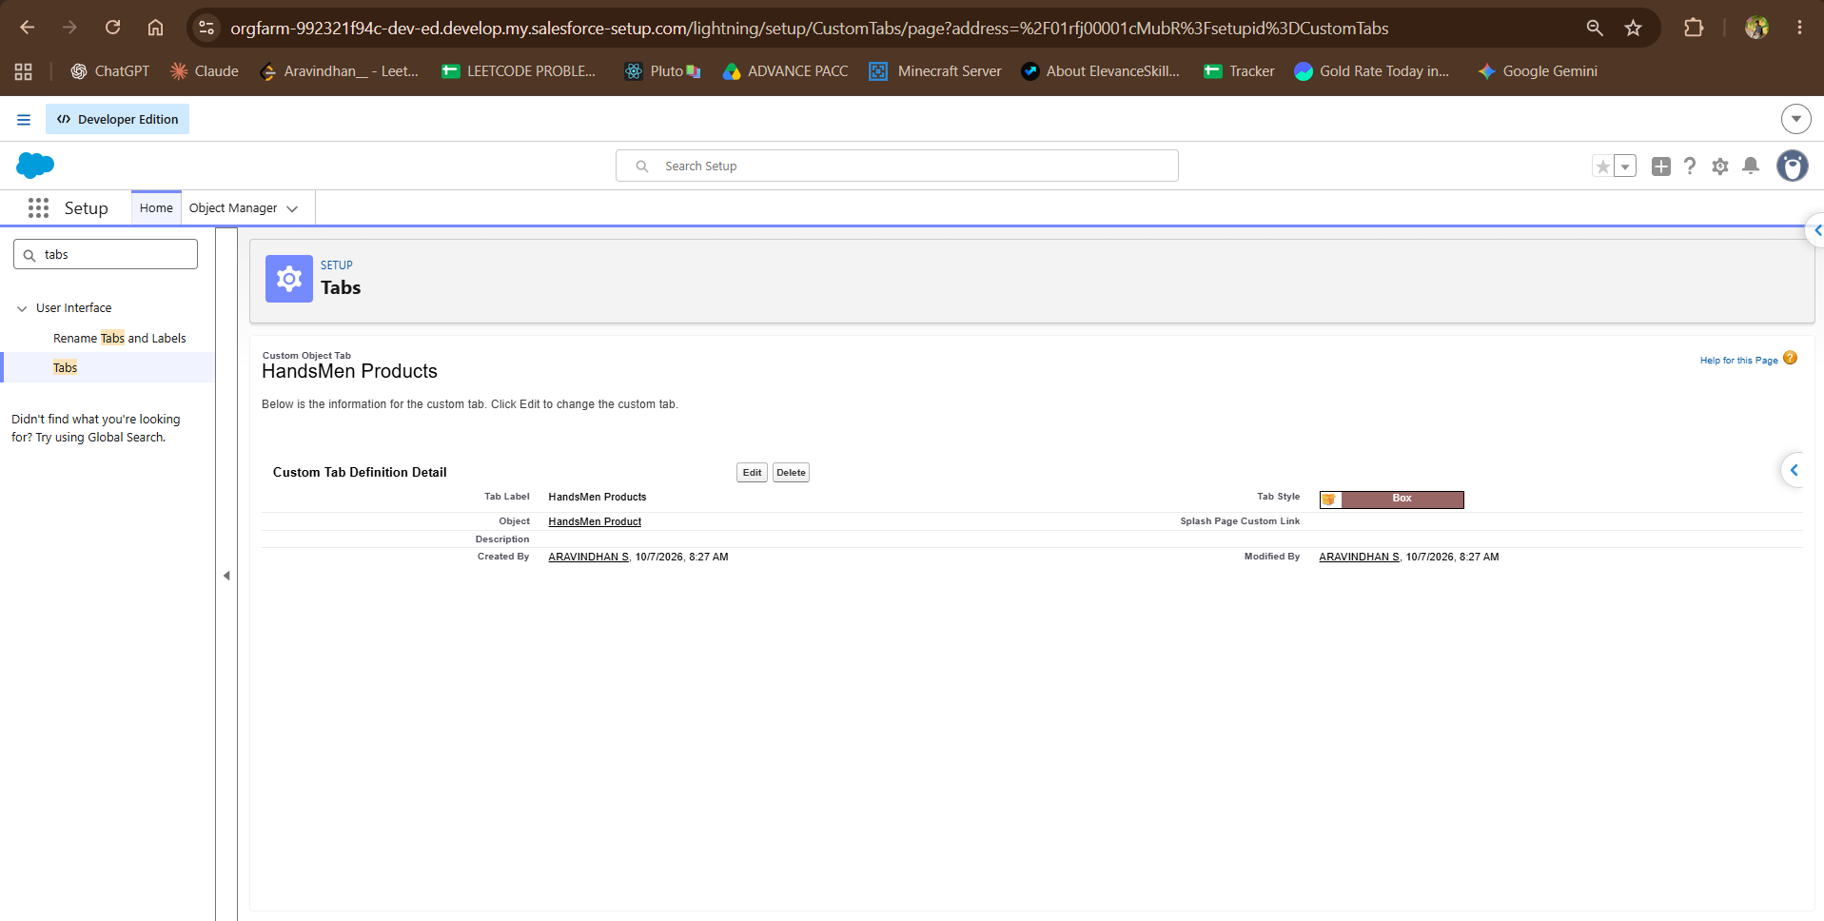
Figure 19. HandsMen Products custom tab definition (Box style, created 7 October 2026).
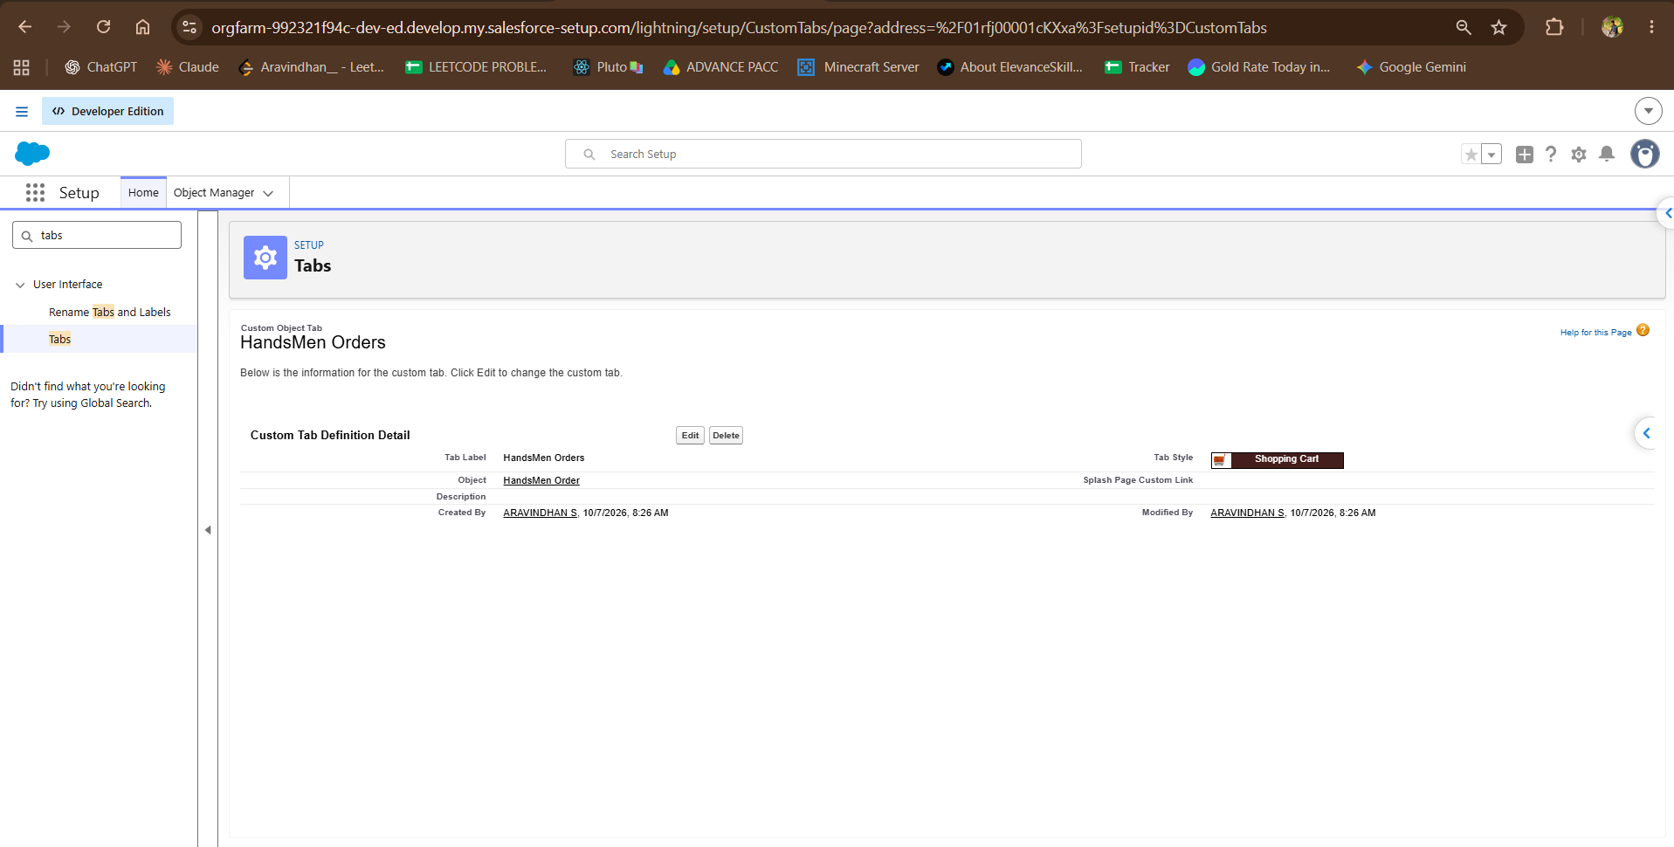
Figure 20. HandsMen Orders custom tab definition (Shopping Cart style, created 7 October 2026).
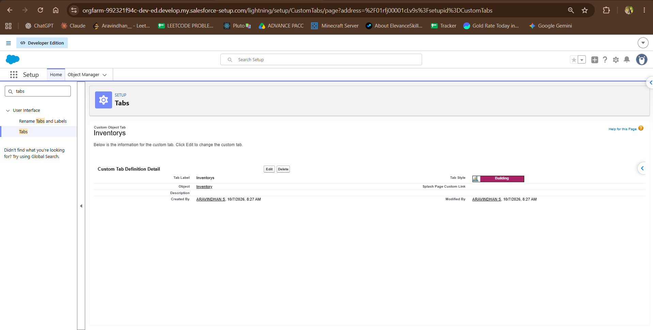
Figure 21. Inventorys custom tab definition (Building style, created 7 October 2026).
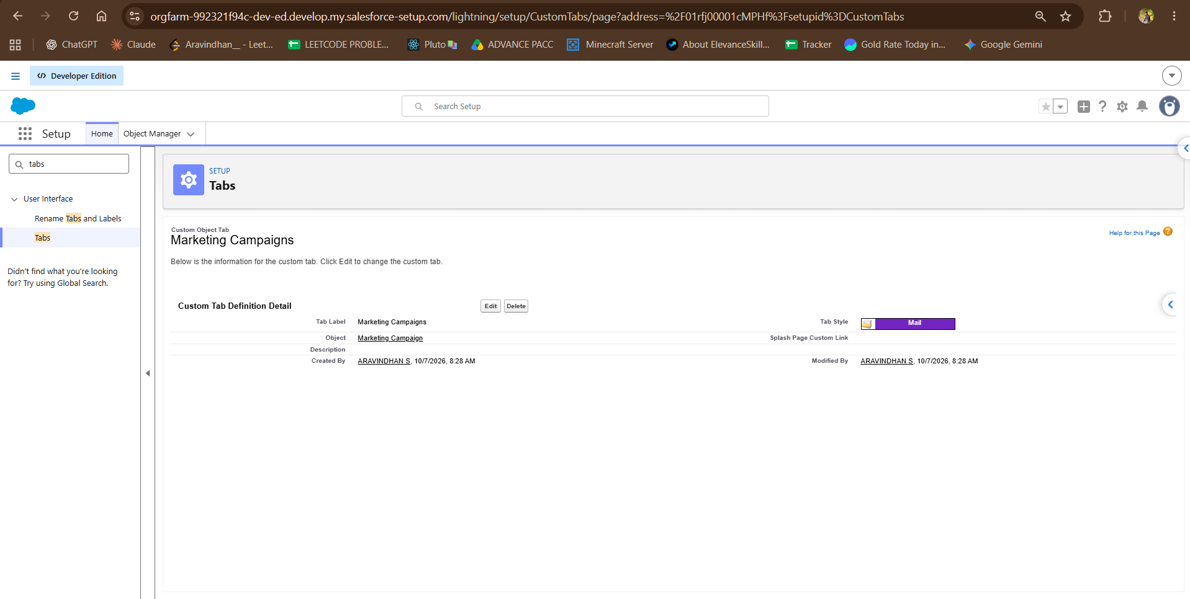
Figure 22. Marketing Campaigns custom tab definition (Mail style, created 7 October 2026).

A.4 Flow Builder and Scheduled Jobs
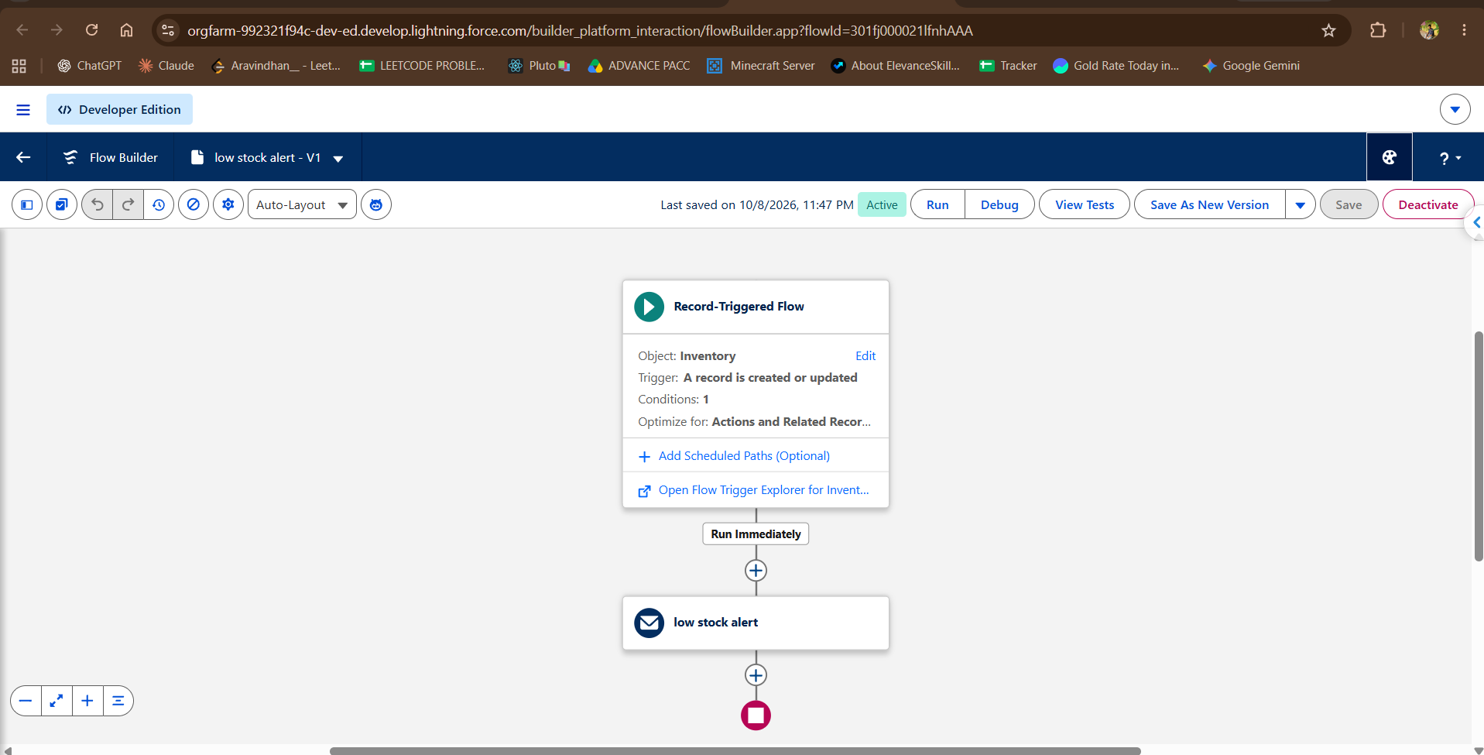
Figure 23. Active record-triggered flow low stock alert - V1 on Inventory, with a Run Immediately path to the low stock alert email action.
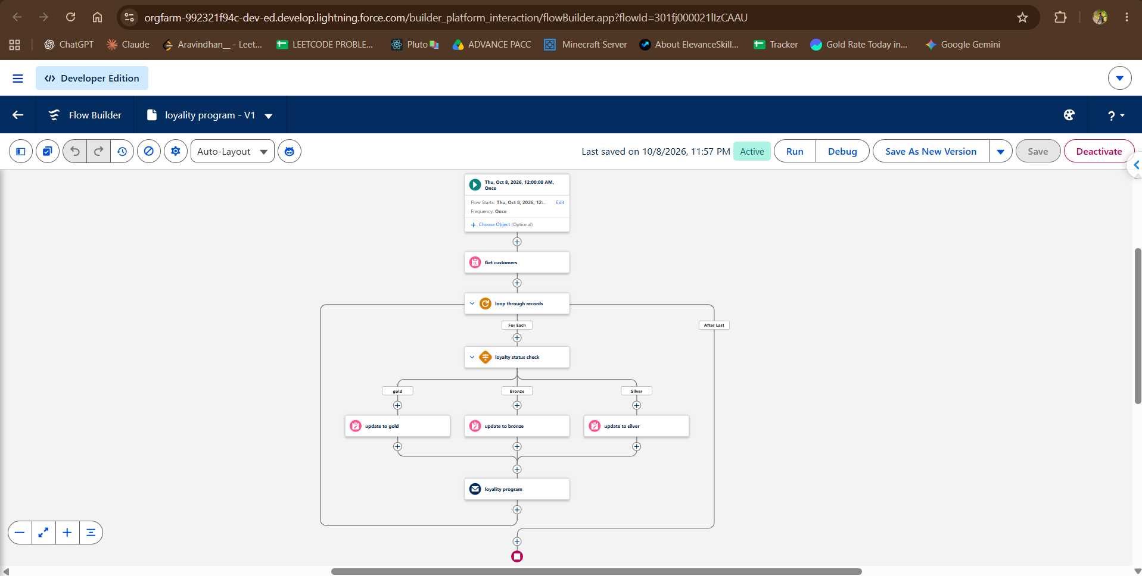
Figure 24. Active schedule-triggered flow loyality program - V1 with gold, Bronze and Silver update paths and the loyality program email action.
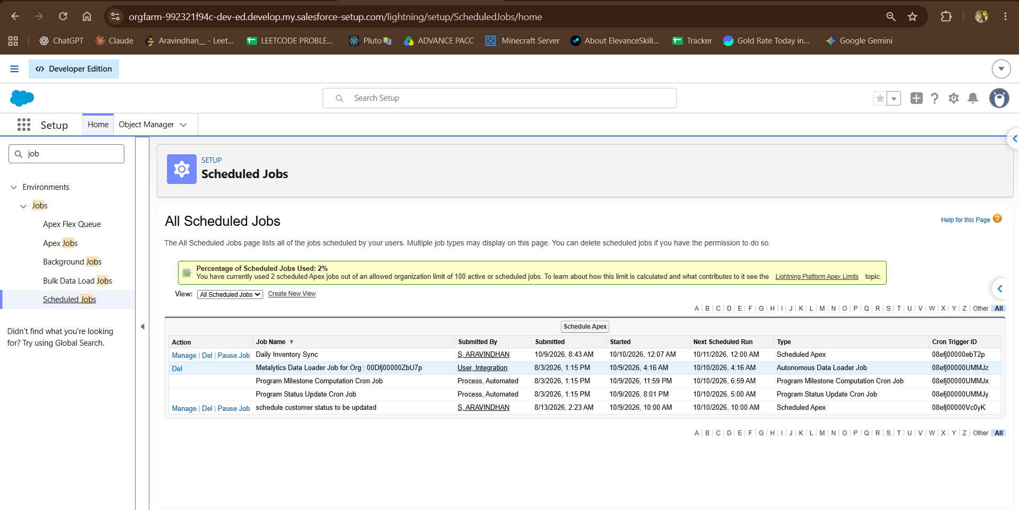
Figure 25. Scheduled Jobs page showing the Daily Inventory Sync and schedule customer status to be updated Scheduled Apex jobs.

A.5 Classic Email Templates and Email Alerts
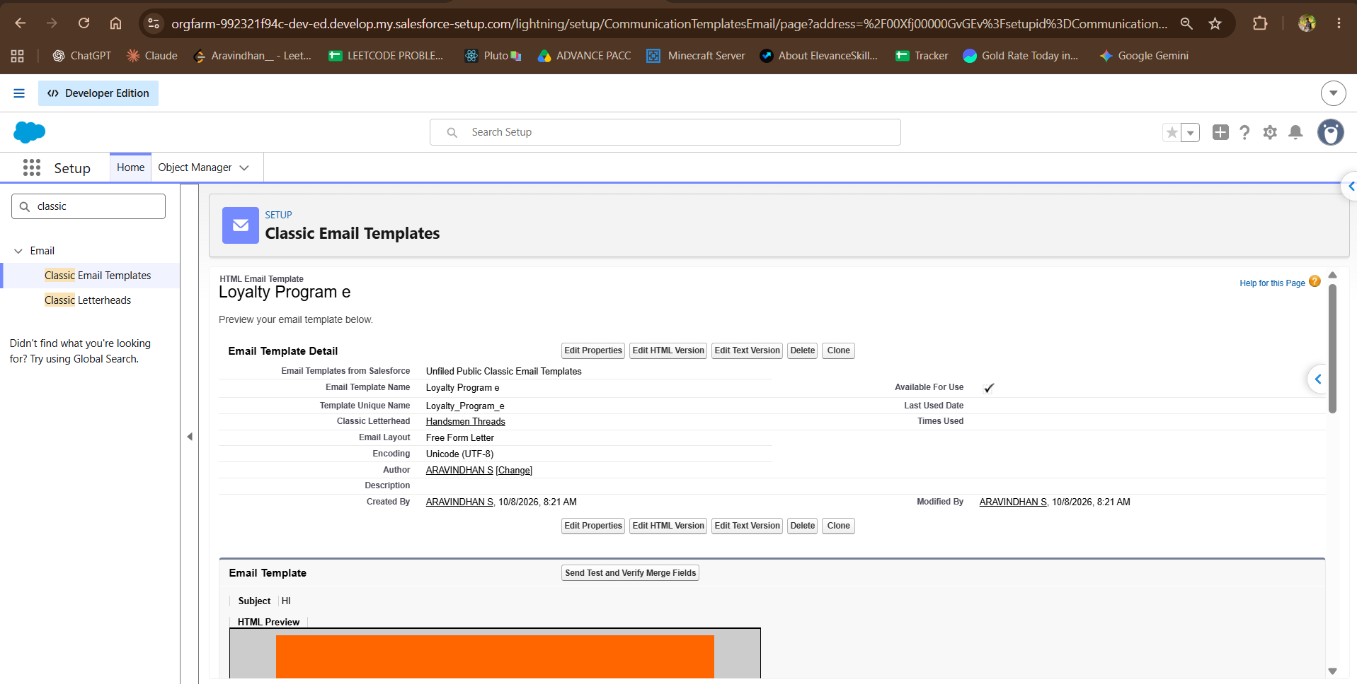
Figure 26. Loyalty Program e classic HTML email template, shown as Available For Use.
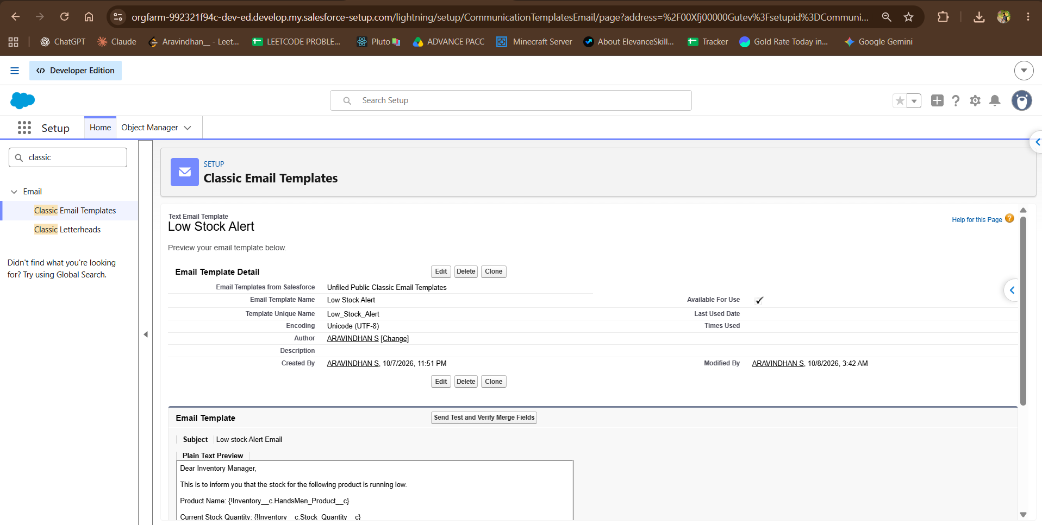
Figure 27. Low Stock Alert classic text email template (subject Low stock Alert Email), shown as Available For Use.
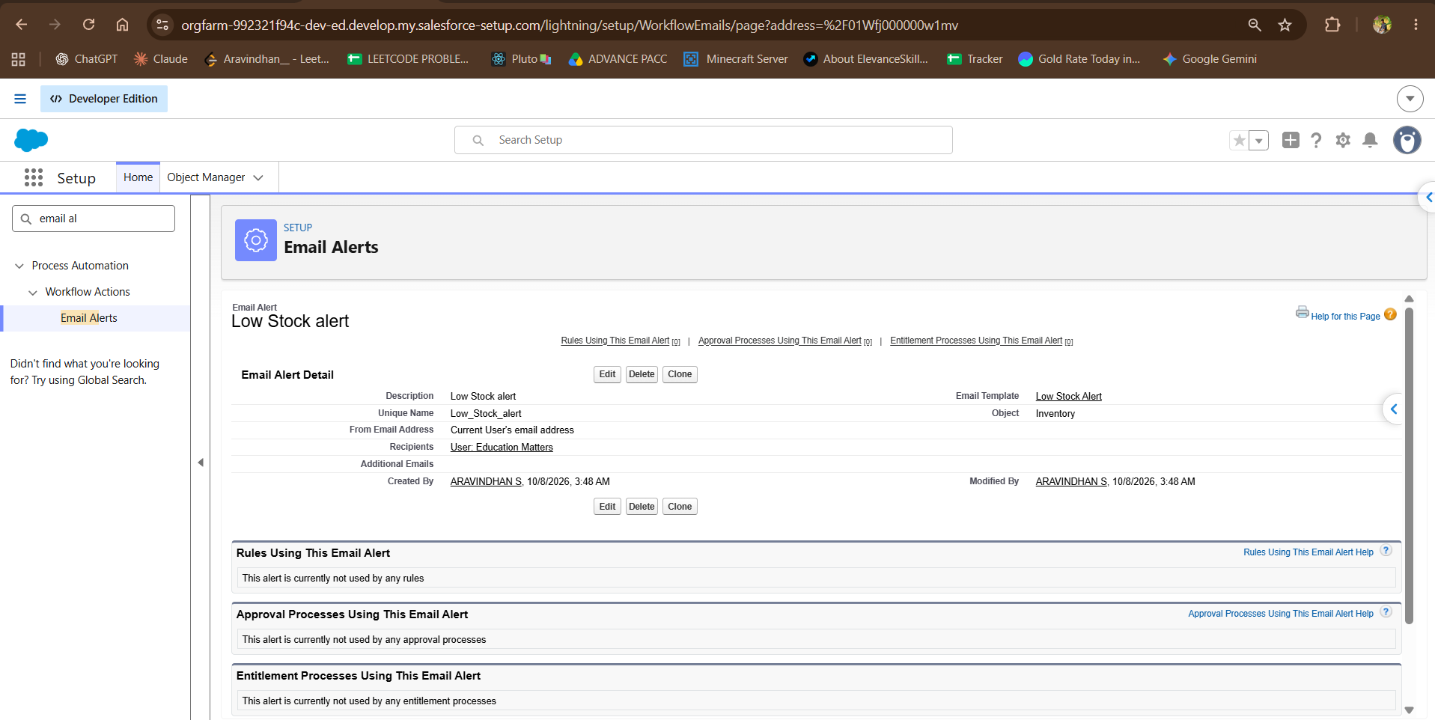
Figure 28. Low Stock alert email alert on Inventory: template Low Stock Alert, recipient set to a named user, sender set to the current user.
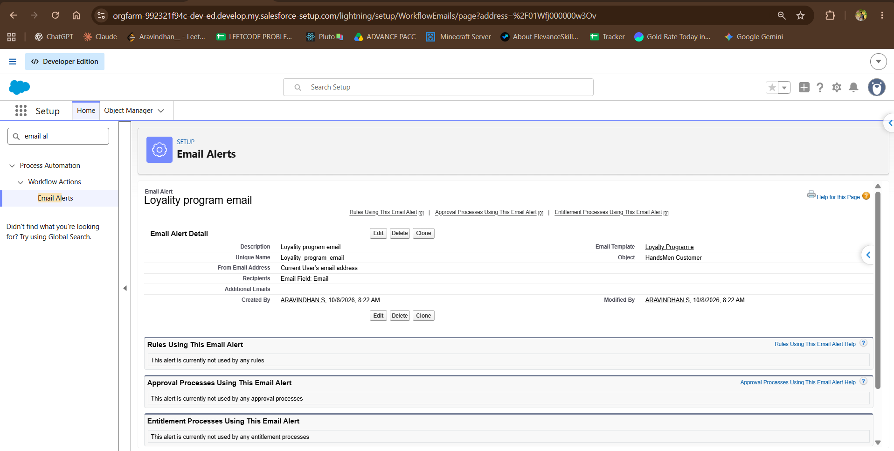
Figure 29. Loyalty program email alert on HandsMen Customer: template Loyalty Program e, recipient taken from the customer Email field.
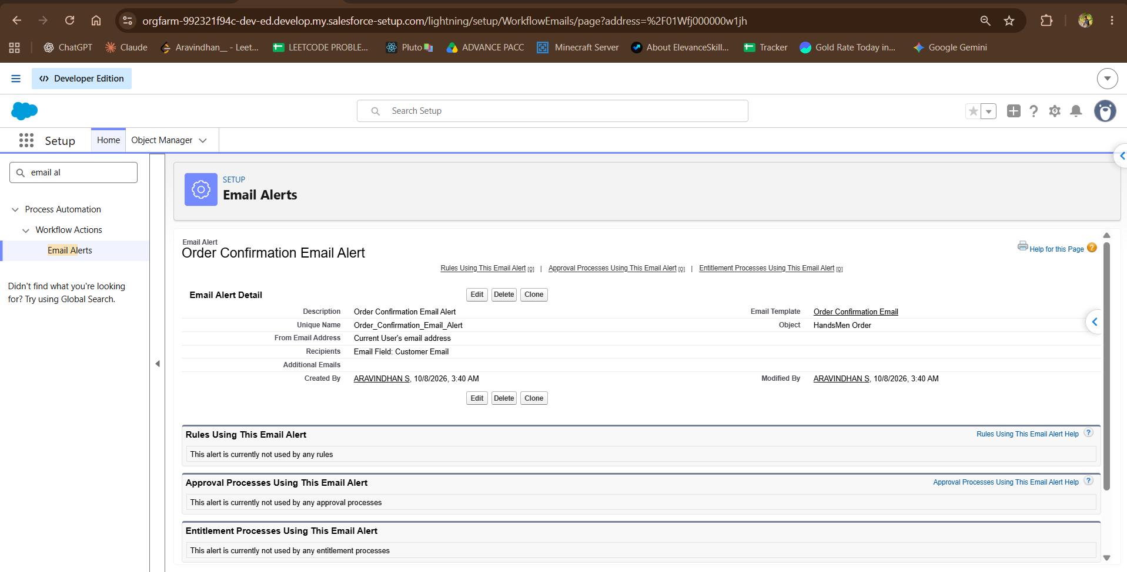
Figure 30. Order Confirmation Email Alert on HandsMen Order: template Order Confirmation Email, recipient taken from the Customer Email field.

A.7 Sample Records
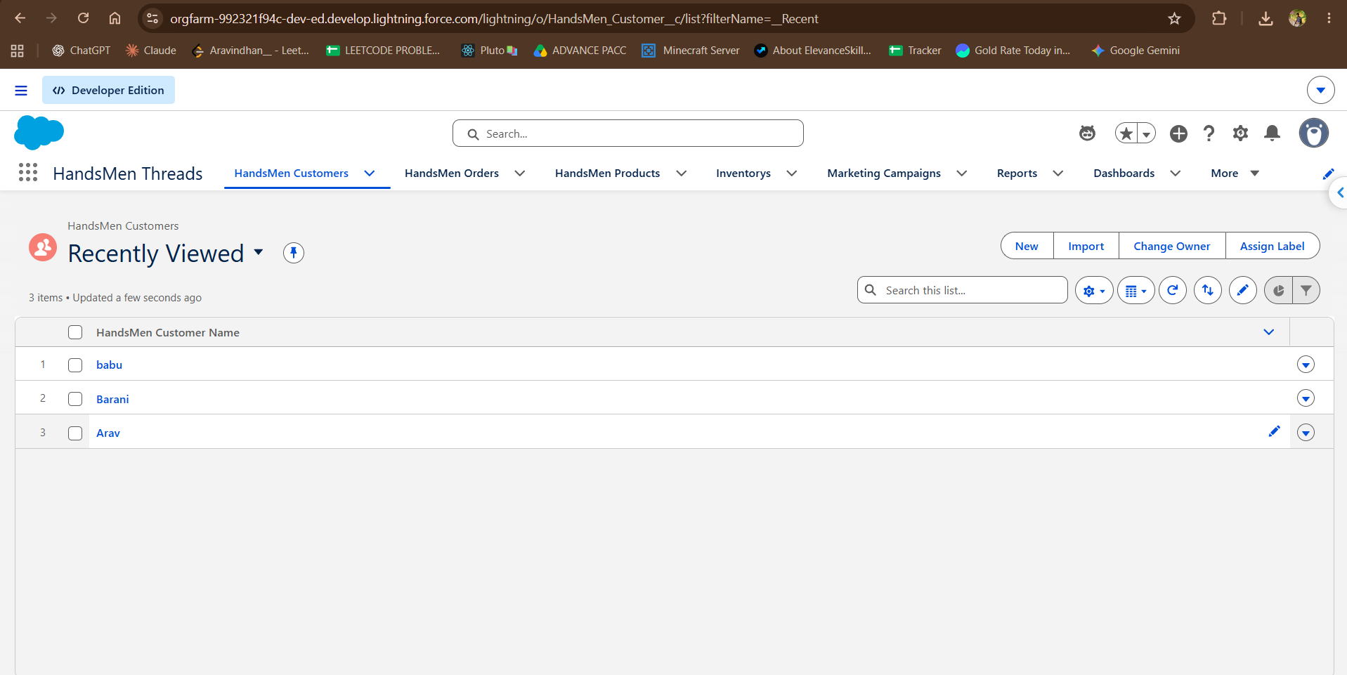
Figure 31. HandsMen Customer list view showing the sample customer records babu, Barani and Arav.
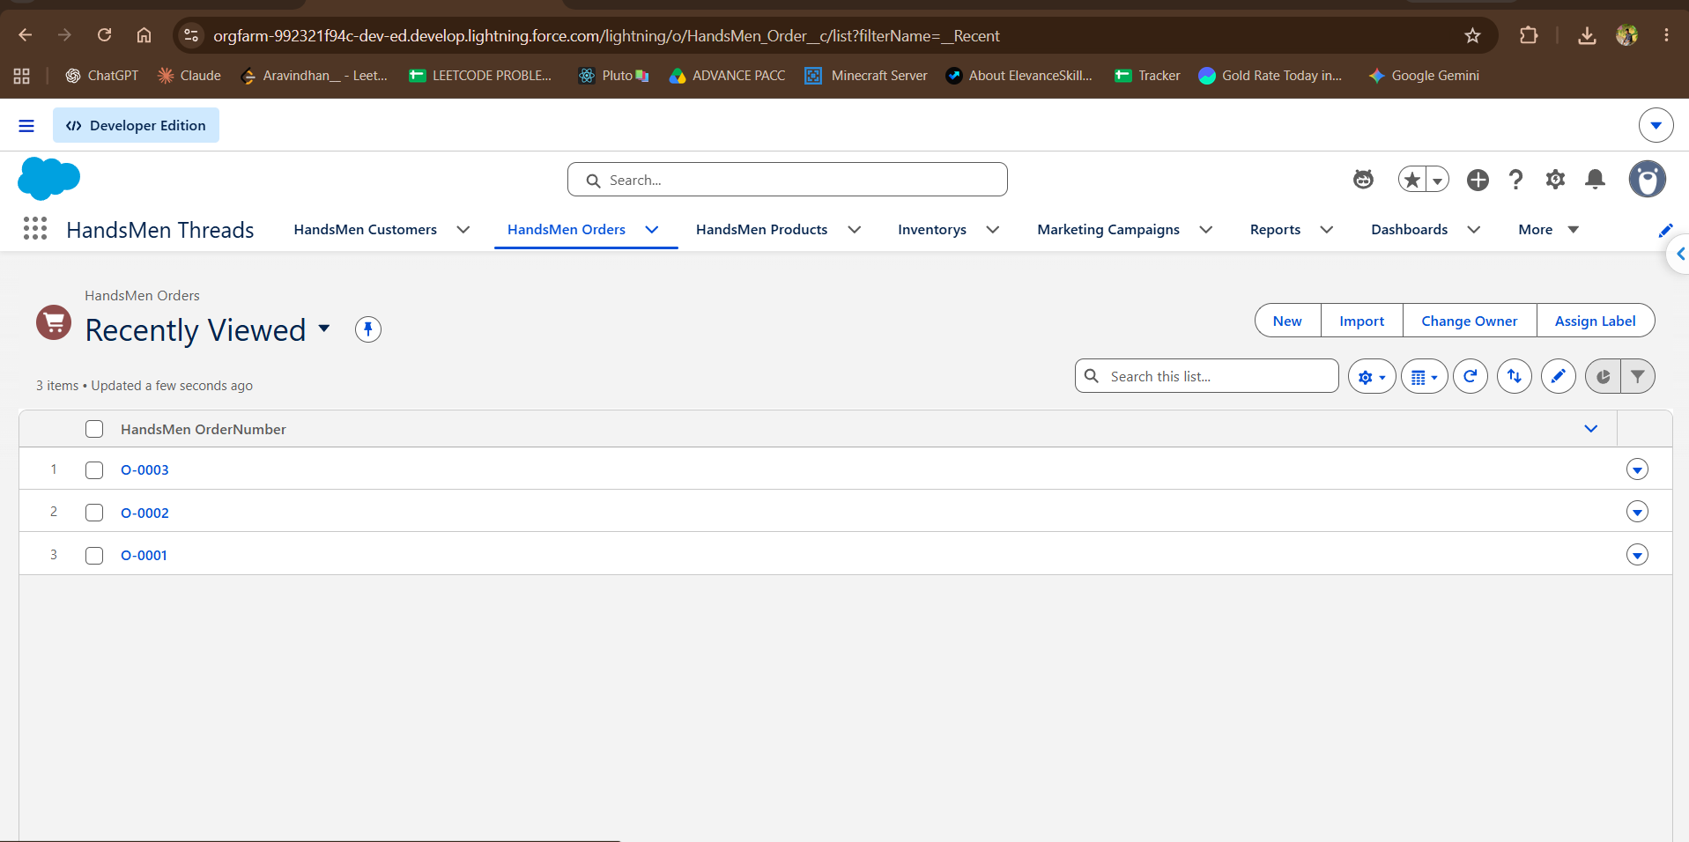
Figure 32. HandsMen Order list view showing the sample orders O-0001, O-0002 and O-0003.
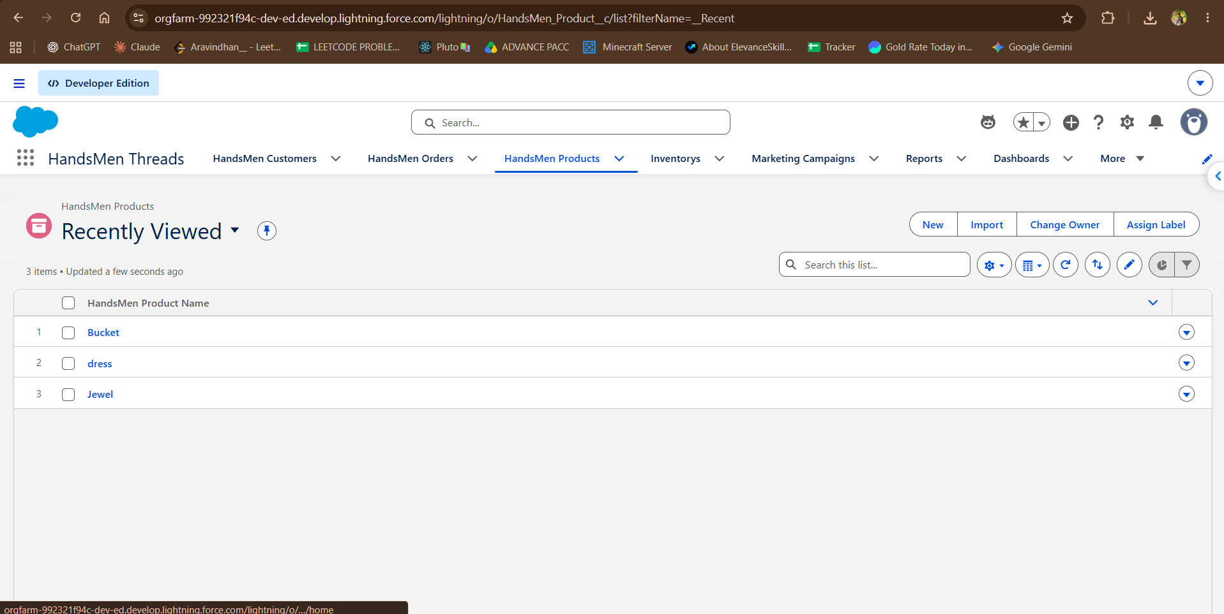
Figure 33. HandsMen Product list view showing the sample products Bucket, dress and Jewel.
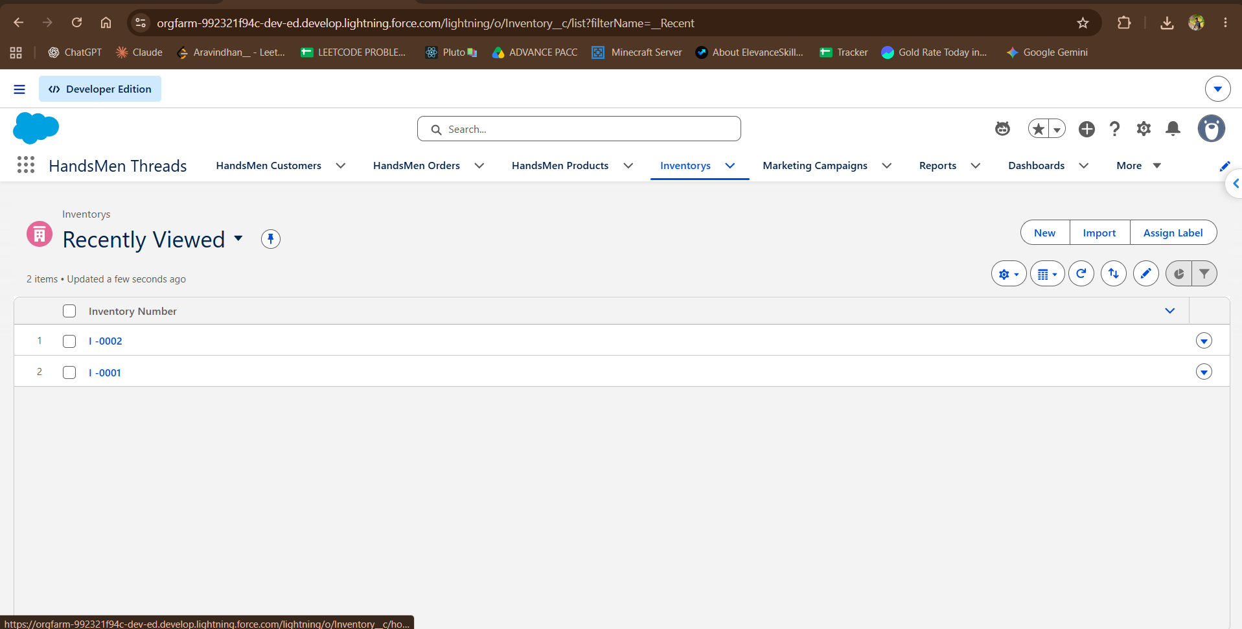
Figure 34. Inventory list view showing the sample inventory records I-0001 and I-0002.
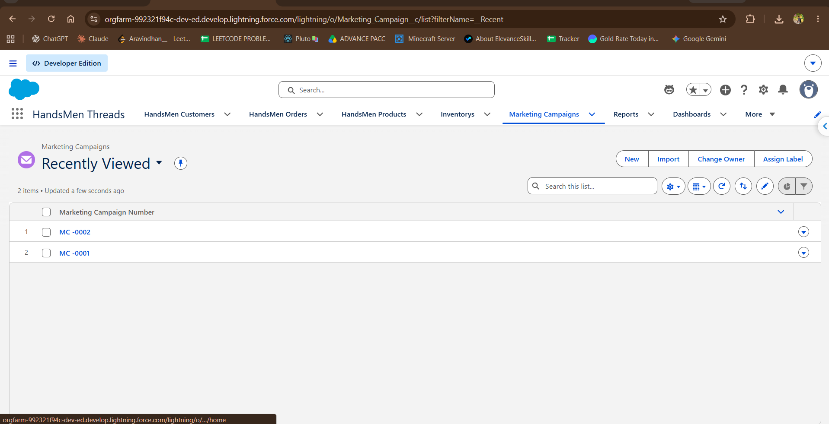
Figure 35. Marketing Campaign list view showing the sample campaigns MC-0001 and MC-0002.

A.8 Validation Testing
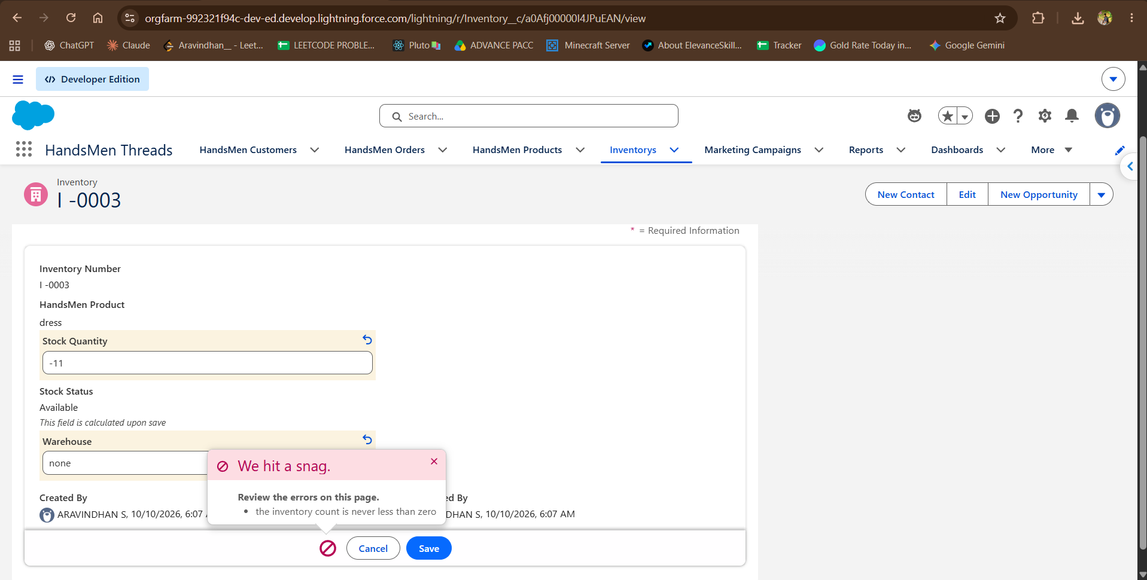
Figure 36. Inventory validation test: a Stock Quantity of -11 is rejected with the message the inventory count is never less than zero.
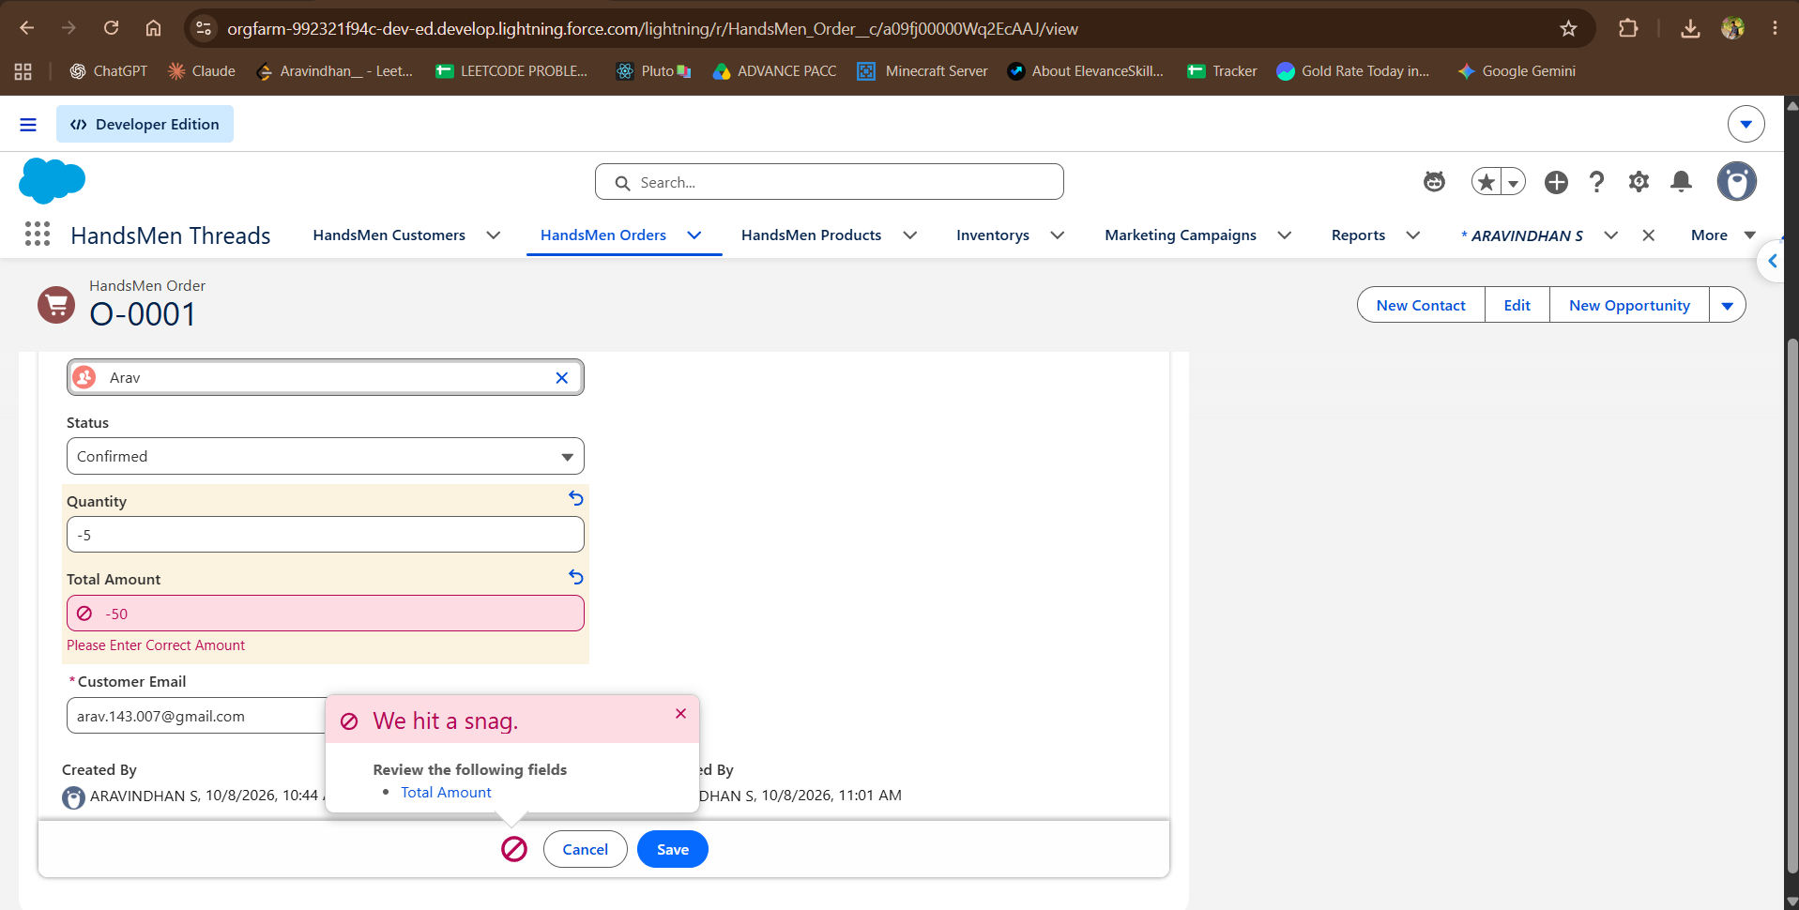
Figure 37. HandsMen Order validation test: a Total Amount of -50 is rejected with the message Please Enter Correct Amount.
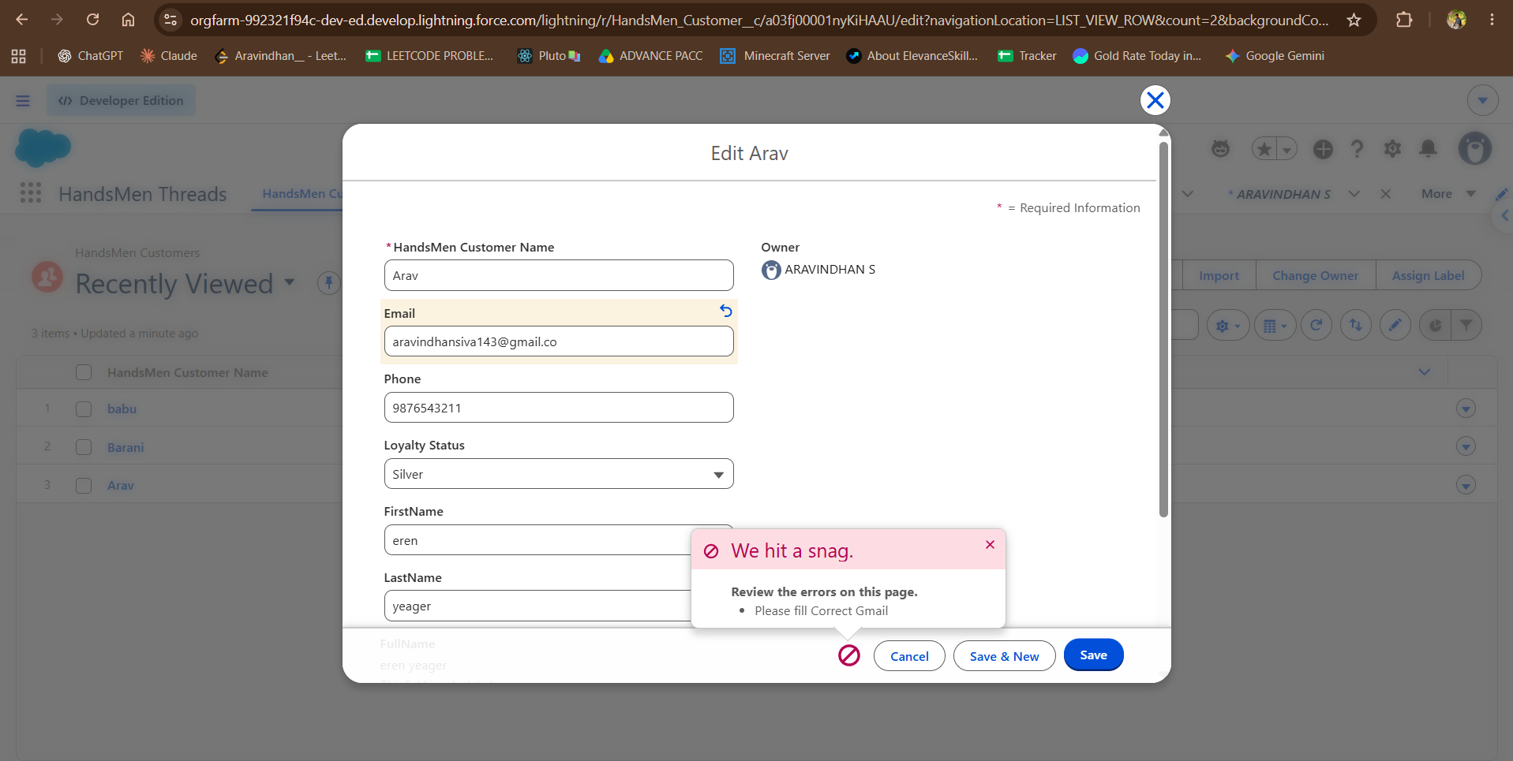
Figure 38. HandsMen Customer validation test: an invalid email value is rejected with the message Please fill Correct Gmail.

A.9 Flow Debug Runs
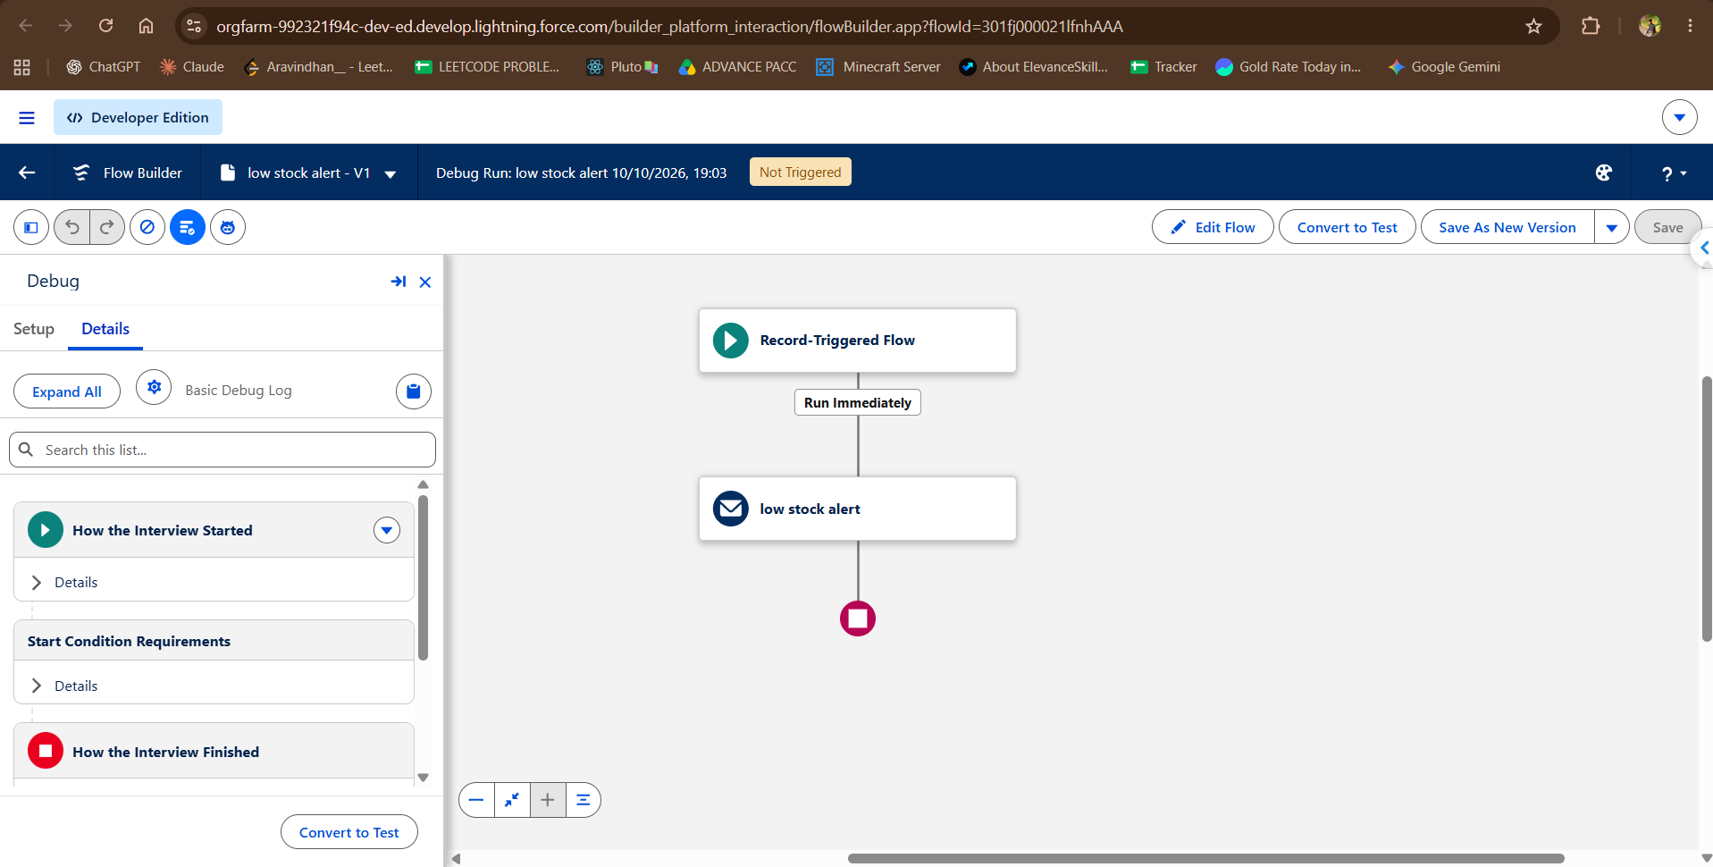
Figure 39. Debug run of low stock alert - V1 on 10 October 2026 (19:03) with status Not Triggered.
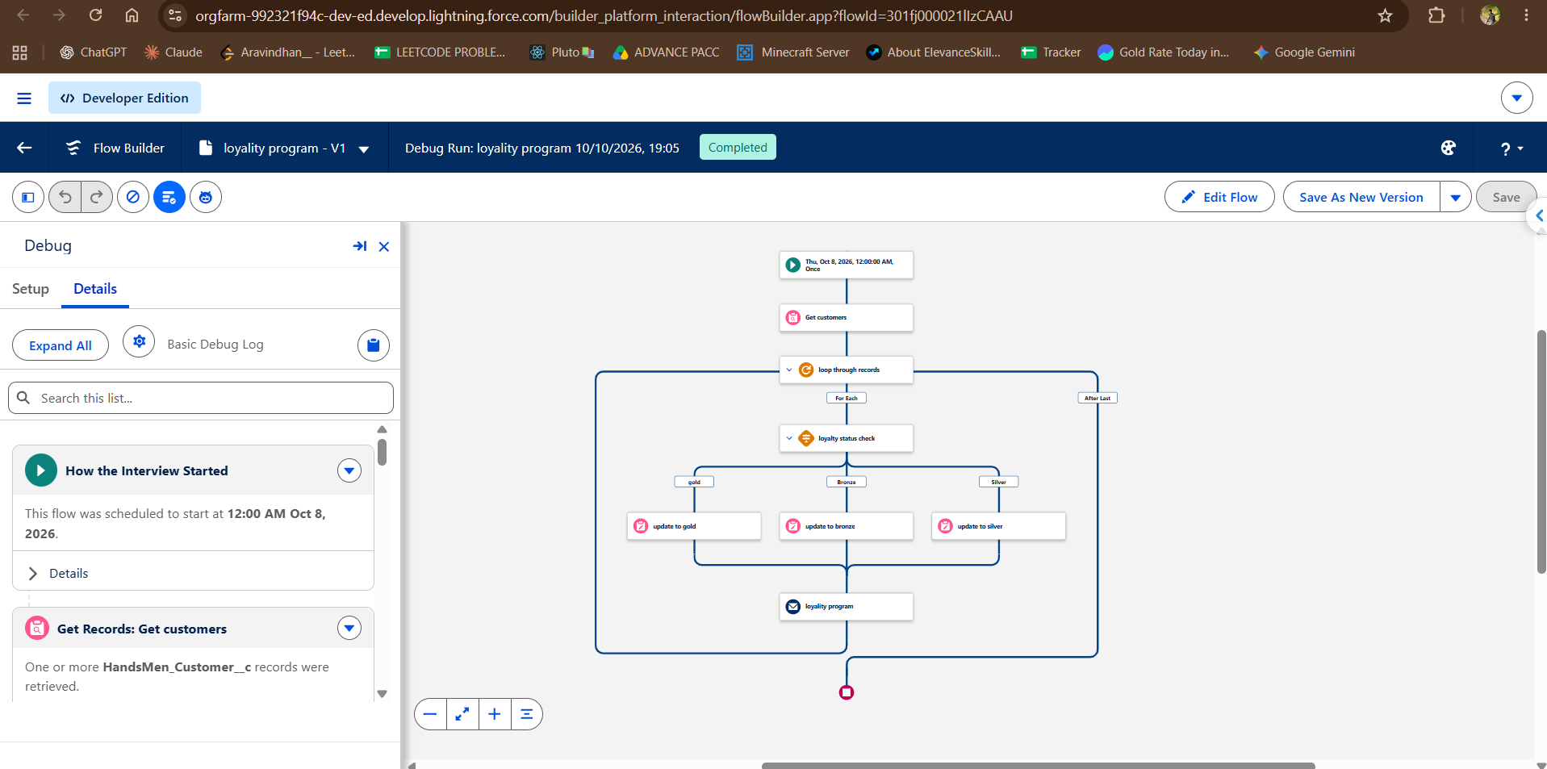
Figure 40. Debug run of loyality program - V1 on 10 October 2026 (19:05) with status Completed; Get Records retrieved HandsMen_Customer__c records.

